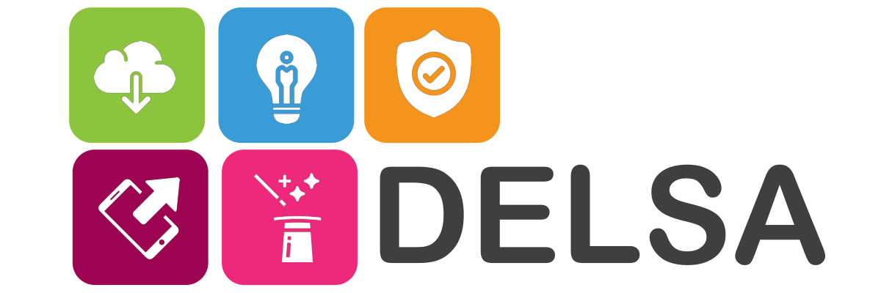

Digital Empowerment for Up-Skilling Adults
2018-1-IE01-KA204-038771

http://www.digitaldelsa.eu/index.php
IO2 - Mapping of Digital Skills & Competencies
May, 2019
Composite Country Snapshot Report

Report Prepared by Michael Kenny, DELSA Project Principle Investigator (PI), Department of Adult & Community Education, Maynooth University (Ollscoil na h’Éireann Má Nuad), and Sinead Hyland, DELSA Project Research Assistant, with contributions from DELSA project partners.

This project has been funded with support from the European Commission.
This publication reflects the views only of the author, and the Commission cannot be held responsible
for any use which may be made of the information contained therein.

The DELSA Project: A Summary
The DELSA project is a five country ERASMUS+ project designed to address the need across Europe to provide concrete training and educational resources for adults to advance their digital competencies and skills. The DELSA project supports the development of basic transversal digital skills based on a bottom-up and demand driven approach informed by the expertise and experience of adult education practitioners and technical experts. The innovative DELSA project method proposes to apply an open approach for the exploitation of results through an open education resource (OER) platform. The DELSA platform will not only be available for learning and capacity building in citizen digital skills but also for networking and cross-border integration.
The DELSA project is a response to specific need for upskilling lower skilled adults in digital skills. The DELSA project identified upskilling in digital skills due to the relevance of digital skills in a modern European social and economic environment. The DELSA project contributes to the integration of digital solutions and ICT in adult learning and education by developing, testing, validating and deploying a full scale OER platform that will mainstream project results across the EU member countries. Improving digital skills and competencies of lower-skilled adults will enhance their socio-economic empowerment and increase their employability.
The DELSA project pools the expertise and capacity of eight partners from six countries representing the various dimensions of adult education for lower-skilled adults with a strong emphasis on digital skills. The DELSA project partnership encompasses public sector, private sector, adult education formal and non-formal providers and an ICT technical partner.
The DELSA ERASMUS+ (Cooperation for innovation and the exchange of good practices) Project pools the expertise and capacity of eight partners from five countries and one pan-European partner representing various dimensions of adult education for low-skilled adults. The project partnership encompasses public sector, private sector, adult education formal and non-formal providers and ICT/Technical partners. Roles within the project are distributed among partners to capitalise on their specific expertise and carry out the following activities:
Activity 1: Develop the DELSA OER Platform for FREE and OPEN access to digital skills learning
Activity 2: Assess specific capacity and training gaps in digital skills for low skilled adults
Activity 3: Develop concrete and user-friendly educational tools and content
Activity 4: Deliver digitally upskilling to at least 200 Adults to increase their digital competencies
This document presents an overview snapshot of EU wide digital skills. Its’ purpose is to:
- Provide the reader with a ’Snapshot’ of digital competency and capacity for upskilling adults in Europe
- Provide an overview of digital competency needs relative to digital provision
- Provide a foundation for proposed digital skill training content for upskilling adults, and for Identifying digital skill modules to be developed in IO3 of the DELSA Project.
- To populate the Project open education resource (OER) for the purpose of open source free digital skill training for lower skilled adults.
- Provide country level data for the project Intellectual Output (IO) 2 Mapping of Digital Skills & Competencies Project report as required in the project contract.
Report Contents
The DELSA Project: A Summary 2
1. Adult Learning Participation 4
2. EU-wide DESI Profile: 8
3. Recommendations for DELSA IO3 courses 14
3.1. DELSA Project Course Topic Recommendations 15

This DELSA Project Composite Report IO2 - Mapping of Digital Skills & Competencies is prepared following the preparation of a digital skills & competencies country snapshot by each partner in the DELSA Project; Hungary, Ireland, Italy, Poland and Spain. The remaining project pan-European partner prepared an EU level snapshot of digital skills & competencies. The outcomes of each of these snapshots, stored on the DELSA project website, were amalgamated to produce this composite report.
The purpose of this report is to provide a foundation and direction for digital upskilling adult learning content that will be hosted on the DELSA Project Open Educational Resource (OER). Providing appropriate digital learning content for upskilling of adult learners with enhance economic opportunities and access to services for lower skilled adults particularly those in more remote areas of Europe.

Adult Learning Participation
Lifelong learning encompasses all learning activities undertaken throughout life with the aim of improving knowledge, skills and competencies within personal, civic, social or employment-related perspectives. Adult learning refers to the participation of adults in lifelong learning after the end of initial education. The measurement indicator for lifelong learning is defined as the share of people aged 25 to 64 who stated that they received formal or non-formal education and/or training in the four weeks preceding the survey. Within the definition of lifelong learning it is critical to be aware of how learning is distinguished from non-learning activities such as cultural or sporting activities. One target under the strategic framework for European cooperation and training (ET 2020) is that, at European level, an average of at least 15 % of adults should participate in lifelong learning by 2020.
The EU Education and Training (ET) 2020 plan proposes the following four common objectives:
- Make lifelong learning and mobility a reality;
- Improve the quality and efficiency of education and training;
- Promote equity, social cohesion, and active citizenship;
- Enhance creativity and innovation, including entrepreneurship, at all levels of education and training.
Results from the European Union (EU) labour force survey show that in 2018 the EU adult participation in learning rate was 11.1 %, a 0.2 percentage (%) points increase above the rate for 2017. The rate has increased gradually from 2015 when it was 10.7 %.
Table 1. Adult Learning % Participation Rates, 2018.
Hungary | 6.0%
Ireland | 12.5%
Italy | 8.1%
Poland | 5.7%
Spain | 10.5%

The Adult Participation in Learning rate figures for DELSA project partner countries are shown in Table 1. Ireland is the only partner country with an average participation rate above the European average. The rate in Poland and Hungary is 50% less than Ireland, Italy at 8.1% and Spain at 10.5%. Therefore, the DELSA project partnership represents a spread of levels of adult participation in learning
The adult participation rates in learning in the EU Member States, 2018, show the highest rates of adult learning participation were in Sweden (29.2 %), Finland (28.5 %) and Denmark (23.5 %). In contrast the five member states with rates below 5 % were Romania (0.9 %), Bulgaria (2.5 %), Croatia (2.9 %), Slovakia (4.0 %) and Greece (4.5 %).
Between 2013 and 2016, the lifelong learning indicator for the EU as a whole did not change significantly in Belgium, Croatia, Lithuania, Malta, and Portugal. In contrast participation rates increased by 1.0 percentage point or more in Estonia, Italy, Finland, and Sweden. Decreases by over 1.0 percentage points were recorded in the United Kingdom, the Czech Republic, Ireland, and Luxembourg. On average across the EU the 2018 adult learning participation rate among women was higher at 12.1 % than the rate among men at 10.1 %.
The following table summarises adult learning participation rates in each EU country in 2010 and 2016. The table also shows if the rate is increasing or decreasing over that time.

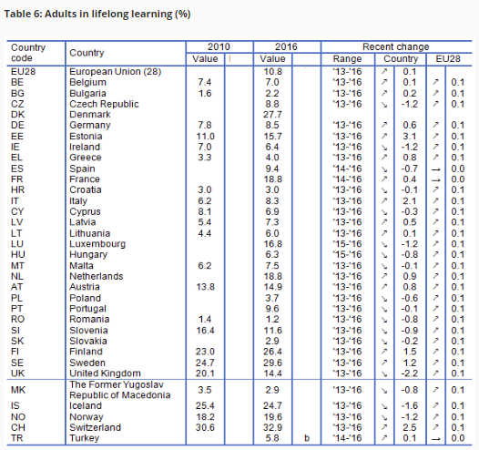

EU-wide DESI Profile:
Fig.1. Legend: EU 28 Country Name abbreviations
.. = the DELSA Project participants
- AT - Austria
- BE - Belgium
- BG - Bulgaria
- CY - Cyprus
- CZ - Czech Republic
- DE - Germany
- DK - Denmark
- EE - Estonia
- ES - Spain
- FI - Finland
- FR - France
- GB - United Kingdom
- GR - Greece
- HR - Croatia
- HU - Hungary
- IE - Ireland
- IT - Italy
- LT - Lithuania
- LU - Luxembourg
- LV - Latvia
- MT - Malta
- NL - Netherlands
- PO - Poland
- PT - Portugal
- RO - Romania
- SE - Sweden
- SI - Slovenia
- SK - Slovakia
The Digital Economy and Society Index (DESI) is a composite index that summarises relevant indicators on Europe’s digital performance and tracks the progress of EU Member States in digital competitiveness.
There are five dimensions in the Digital Economy and Society Index
1 Connectivity | Levels of fixed broadband, mobile broadband, fast and ultrafast broadband and prices
2 Human capital | Internet user skills and advanced skills
3 Use of internet | Citizens' use of internet services and online transactions
4 Integration of digital technology | Business digitisation and e-commerce
5 Digital public services | e-Government and e-health
According to e-Europe’s 2017 DESI Report, Finland, Sweden, the Netherlands and Denmark, have the most advanced digital economies in the EU followed by the UK, Luxembourg, Ireland and Estonia. Bulgaria, Romania, Greece and Poland have the least advanced digital economies in the EU (See Fig.1. Legend for EU country abbreviations).
Readers can see the distribution of DESI scores (Fig.2). The DELSA project partners represent 5 countries Spain, Hungary, Ireland, Italy and Poland. The reader can see that Ireland (IE) and Spain (ES) score above the EU average but Hungary (HU), Poland (PL)and Italy (IT) score significantly lower. The individual scores for five DESI score categories (Connectivity, Human capital, Use of internet, Integration of digital technology, and Digital public services), provides granular data that assists the reader determine the importance of education and training in addressing digital upskilling for adult learners.

Fig.2.
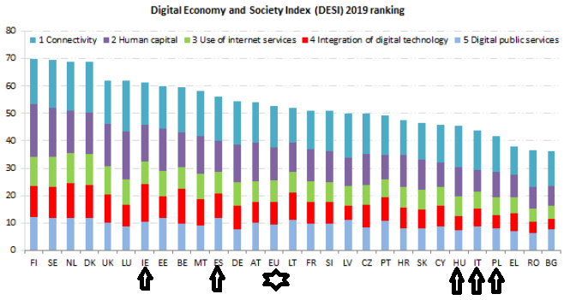
Connectivity
Basic broadband is available to almost 97 % of EU homes when all major technologies (xDSL, cable, fibre to the premises - FTTP, WiMax, HSPA, LTE and satellite) are accounted for. There is a high level of connectivity available to EU citizens across all EU member states. Rural area coverage is 87% but 13% of rural homes are not covered by any fixed network and 48 % by any NGA technology.
Fig.3.
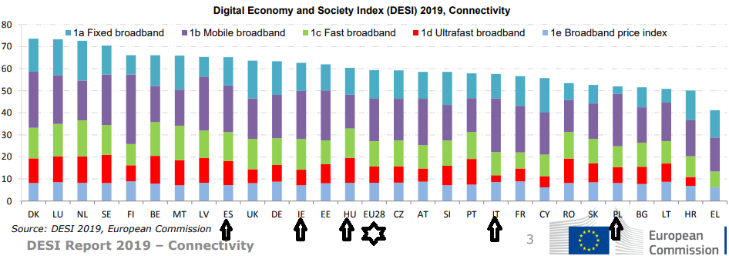

Human Capital
According to DESI data, Luxembourg, the Netherlands and Sweden are the top performers in terms of internet user skills, whereas Finland, Sweden and Estonia have the highest scores in advanced skills and development. Bulgaria, Romania, Italy and Greece rank the lowest overall on DESI's Human Capital dimension
Fig.4.
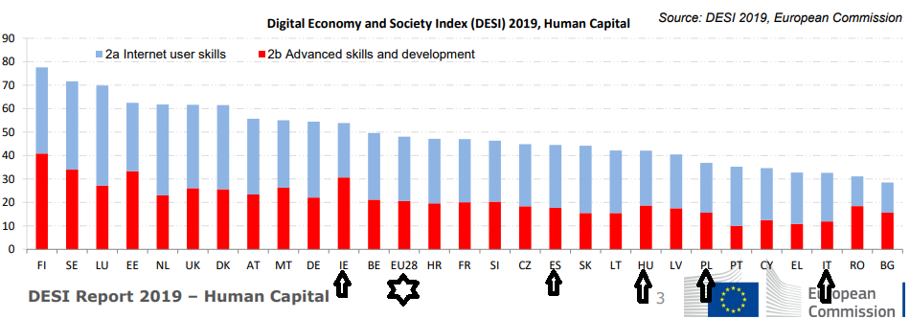
17% of the EU population had no digital skills in 2017, and 43% of the EU population had an insufficient level of digital skills. Only about 31% of people with low or minimum education levels have, at least, basic digital skills. While there are major disparities across member states and pronounced greater digital skill disadvantage in rural areas there is a correlation between low level of digital skills and low levels of connectivity.
Use of Internet
Denmark, the Netherlands, Sweden and Finland are the most active internet users. Citizens in Romania, Bulgaria and Greece are the least active. All five country partners in the DESA project are below the EU average in internet use but Ireland and Italy have the largest internet use improvement (See Figure 3.).
Respondents give three dominant reasons for not having internet access at home. 46 % of households without internet access in 2017 report a lack of need or interest in having internet connection. 43% report insufficient skills for internet use. 32% give high access and equipment costs as their reason for not having internet access at home. However the correlation between lack of human capital – digital skills, and use of internet is clear. There are significant disparities in citizen digital skill across member states and pronounced greater digital skill disadvantage in rural areas. This disparity is mirrored in poorer uptake of digital connectivity.

Fig.5.
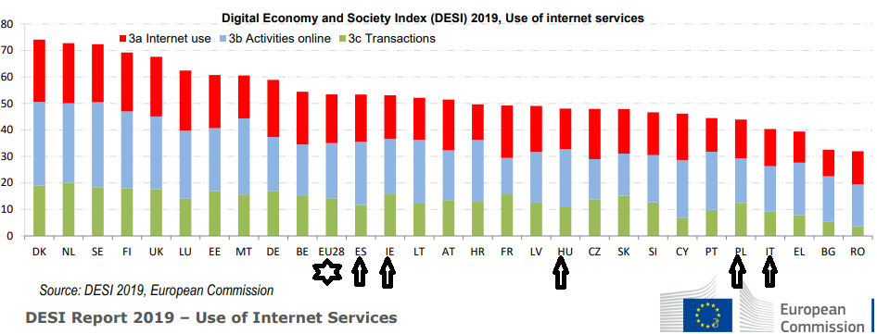
Lack of relevant skills is the fastest-growing factor deterring households from having home internet access. Those without internet access are also least aware of potential benefits from digitization. Therefore, in a “Catch 22” scenario, their lack of knowledge of benefits of digital connectivity explains why large numbers of EU households still claim they do not need have internet access.
Integration of Digital Technology
Ireland, the Netherlands and Belgium scored highest in Integration of digital technology according to DESI. Bulgaria, Romania, Poland and Hungary scored lowest. The spread of scores among the DELSA partner countries is very evident in relation to business digitisation and e-commerce.
Fig.6.
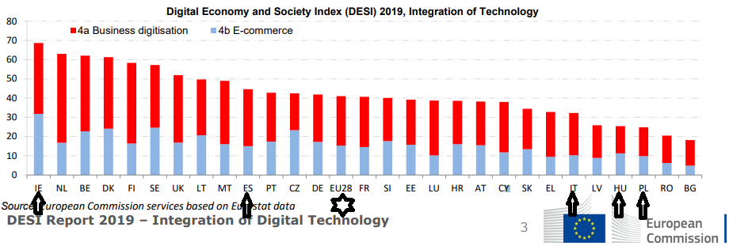
Ireland, Sweden and Denmark have developed e-commerce opportunities the most. The Netherlands and Finland are leading in the adoption of e-business technologies. Bulgaria, Hungary, Romania, Poland, Latvia and Italy lag behind in the adoption of e-business technologies.
Digital Public Services
Finland has the highest score, followed by Estonia, the Netherlands and Spain, in digital public service access. Romania, Greece and Hungary and have the lowest scores with Poland and Italy below the EU average.
Fig.7.
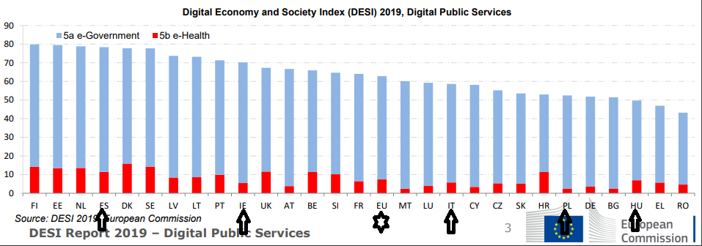
The demand side of digital public services is growing with 64 % of EU citizens now using online public services. Accessing public services online reduces the time citizens spend in public administration offices. In Sweden, Estonia, Finland and Denmark 90 % of internet users in the 16-74 age group choose governmental portals to submit completed forms for public administration purposes.
Ireland, Italy and Latvia reported the most progress in the provision of government services online and the use of inter-connected registers so that users do not have to resubmit data to the public administration.

Conclusion
The reader can conclude the following from the EU wide DESI profile;
- Overall connectivity levels are high (99%)
- Integration of digital technology through business digitisation, e-commerce and digital public service delivery is advancing and becoming commonplace and universal.
- Lack of relevant skill is by far the largest factor deterring households from benefiting from digital services
- Lack of digital awareness and digital skill is a justifying reason for not seeking digital connectivity, therefore a danger of continued digital service and an opportunity exclusion.
- Citizens in the DELSA Project partner countries are just above or significantly below the EU average in digital skill human capacity
Overall this report concludes that human capacity is the most limiting factor in the digital uptake of progressive opportunities and government services. Due to limited human capacity, particularly among lower skilled adults, citizens cannot use services and opportunities for economic and social betterment optimally.

Recommendations for DELSA courses (Project IO3)
Arising from the profile above digital upskilling for lower skilled adults can offer:
- increased efficiency/productivity in their work and businesses;
- improved access to markets to sell and buy goods;
- improved education;
- wider networks;
- new innovations;
- faster access to relevant information.
Digital inclusion is an empowering process giving lower skilled adults a voice. Digital inclusion enables all citizens to effectively participate in the governance processes and innovate to build and shape their future. Indeed, empowerment offers both opportunity and challenge for digital inclusion.
Furthermore, digital engagement and information communication technology (ICT) can enable people to acquire new skills and can act as a catalyst in the delivery of public services such as education, employment, healthcare and financial services. Enhancing digital skills with access to ICT and the Internet offers wider benefits for lower skilled adults including:
- improved health for individuals, their families and communities
- support access to education and other social services, and
- contributes to employment, economic independence and the sustainable development of their livelihoods.
Evidence of future skill needs, wider technological advances, globalisation, demographic changes and other pressures point to the importance of having good data and information available to the citizen. Learning and labour market information allows a broad range of actors to make better choices for a better alignment between skills supply and demand. There is evidence of skills mismatches and uncertainty about current and future skill needs but the digital education and training needs of lower skilled adults is clear. However, lower skilled adults are less likely to have an internet connection and to lack the digital skills to utilise internet connectivity.
While there are information gaps and room for improvement in the design and dissemination of information to lower skilled citizen target groups, the supply side of digital provision is growing and access is widening. Human capability is the cross-cutting limiting factor in optimising information uptake and digital engagement especially among lower skilled adults. Online digital access also offers a balance in the dynamic between citizen needs and citizen services.

3.1. DELSA Project Course Topic Recommendations
Based on the mapping dimensions of digital access and provision presented above, and taking into consideration the DELSA Project partners interaction subsequent to project submission, digital upskilling course topics recommendation are presented following.
Evidence suggests that countries involved in the DELSA project are highly digitally connected with an increasing range of public administration services, employment opportunities and own business opportunities now requiring digital skills. Yet there are significant disparities in digital competencies and the deficit is primarily among lower skilled adults.
The county snapshots prepared for the DELSA Project suggest that it is necessary to upskill adults to make use of their greater connectivity. The evidence from ongoing monitoring of adult competencies via the PIAAC (Programme for the International Assessment of Adult Competencies) suggest that lower skilled adults are more likely to be digitally marginalised because of absent or low levels of digital skills. Further, the lack of digital skills, particularly among those who are economically poorer and/or socially and geographically disadvantaged, is one reason explaining poor digitally connectivity.
The DELSA project partners propose digital upskilling for lower skilled adults addresses lower skill adult learner empowerment and opens the door for wider range skill enhancement. The DELSA project partners are aware that proposed training has to be cognisant of adults different learning needs and contexts. Learning materials to be developed and provided by the DELSA project will offer learning content and delivery appropriate to adults. DELSA learning materials will:
- Build on learners needs
- Develop skills that learners already have
- Chunk learning materials so that they are available in brief modules and units that can be located intuitively
- Use a wide variety of media to adapt learning to the learners own learning style
- Include revision materials that summarise key steps in completing common tasks
- Present learning so that the context and uses for the learning is obvious
Digital learning for lower skilled adults should be presented in relatable modules subdivided into learning units. Units should be no longer than 15 minutes in duration and should be interspersed with reminders, revisions, short ‘how to’ exercises, and encouragement to apply the learning. Learning should be presented in attractive uncluttered screens using commonly used digital screen applications. The applications used should be flexible for access via computer, mobile and tablet devices in fixed or mobile format.
DELSA project partners propose the following content for free open source digital skill learning:
Module 1: Advantages of Digital Information Browsing and Data Literacy
- Unit 1.1: Browsing, searching and filtering information, data and digital content
- Unit 1.2: Evaluating data, information and digital content sources
- Unit 1.3: Managing data, information and digital content
- Unit 1.4: Articulating information needs through search techniques
- Unit 1.5: Locating, retrieving and storing digital data, information and content
- Unit 1.6: Retrieving and organising digital data
Module 2: Easier Communication & Collaboration in the Digital Space
- Unit 2.1: Interacting with people and services using Digital Technologies
- Unit 2.2: Connecting with family, friends and colleagues using Digital Technologies
- Unit 2.3: Saving money – the sharing economy through Digital Technologies
- Unit 2.4: Managing one’s digital identity and reputation
- Unit 2.5: Etiquette/Netiquette for internet and digital communication
- Unit 2.6: Thinking like a digital native
Module 3: Safety Online
- Unit 3.1: Ensuring privacy
- Unit 3.2: Protecting personal data
- Unit 3.3: Protecting health and well-being
- Unit 3.4: Protecting devices
- Unit 3.5: Protecting our environment – digital impact
- Unit 3.6: Ensuring child and vulnerable adult safety
Module 4: Practical Online Tasks
- Unit 4.1: Finding essential websites and media
- Unit 4.2: Online voice and visual communication
- Unit 4.3: Sending and receiving mail/postage electronically - Email
- Unit 4.4: Locating services, making appointments and responding online
- Unit 4.5: Using e-government services
- Unit 4.6: Online marketing, using social media
- Unit 4.6: Starting Online Business, Taking Existing Business Online
- Unit 4.8: Learning online
Module 5: Practical Problem Solving
- Unit 5.1: Adjusting digital settings
- Unit 5.2: Identifying digital competence gaps, needs and technological responses
- Unit 5.3: Getting help online / solving technical problems
- Unit 5.4: Creatively using digital technologies / identifying alternatives
- Unit 5.5: Gaining confidence in doing occasional online tasks
- Unit 5.6: Online job search and CV development
Module 6: Digital Content Creation
- Unit 6.1: Effective use of ICT tools and apps
- Unit 6.2: Web resources for self-empowerment
- Unit 6.3: Programming and developing digital content
- Unit 6.4: Copyright and licences
- Unit 6.5: Making a Living from online activity
- Unit 6.6: Social networks management

Other digital upskilling areas to be considered are:
- ICT supported guidance for digital lower-skilled learners
Make the most of smartphones: tips and tricks
- Networking
- Engaged citizenship through digital technologies
- Email creation and management
- Tools for communication (skype, doodle, WhatsApp, etc.)
- Buying online: dos' and dont's
- Time scheduling and project management

As the proposed topics are in line with the practical experience of DELSA Project partners Intellectual Output 3 of the DELSA project will curate digital learning materials in line with the modules and units identified above. The online DELSA module and unit content will follow universal design and will focus on providing accessible learning to lower skilled adults.

END OF DELSA Composite Report

Up-Skilling is the process of improving learners' skills to help develop new abilities and knowledge that enhance effectiveness and minimize troublesome skills gaps. For further definitions see Cedefop (2014). Terminology of European education and training policy: a selection of 130 terms 2nd ed. Luxembourg: Publications Office.
See https://ec.europa.eu/education/policies/european-policy-cooperation/et2020-framework_en
See https://ec.europa.eu/eurostat/web/microdata/european-union-labour-force-survey
Catch 22 - a dilemma from which there is no escape because of mutually conflicting conditions.

