"Players Must Be of a Good Class": Women and Concert Musicians in Irish Picture Houses, 1910-20

Denis Condon
“Good music will invariably command audience,” an unnamed writer argued in the Irish Limelight, Ireland’s first cinema journal, in 1918, “and in Ireland, where we have an intensely musical people, the coming of the cinema orchestra has been enormously beneficial to those whose craving for music in an easily accessible form was previously almost entirely ignored.” Scholars of Irish music have also long noted the impact of the advent of the cinema orchestra on the country’s – and more specifically, Dublin’s – wider musical culture. “[T]he mushroom growth of cinemas in the city from 1913 on had an adverse effect on concert attendances, resulting in a drastic decrease in the number of concerts given,” observes composer and University College of Cork professor of music Aloys Fleishmann. “At first music for the films was supplied by a pianist. Then, competing with each other, the cinemas began to use instrumental combinations of up to ten players, engaging the best local soloist and even importing musicians from abroad.” Although Fleishmann argues that cinema music had a negative impact on concert attendance, he acknowledges that it promoted string playing by offering career opportunities for string musicians. The Limelight writer also focused much of his/her article on a male soloist and a female accompanist, thereby touching on arguably the two most remarkable features of Irish cinema music of the 1910s: the prominence in Dublin’s picture houses of women musicians in the early part of the decade and of the finest concert instrumentalists in the latter part. A focus on musicians reveals fascinating details of how films were accompanied in the 1910s.
The Limelight article will bear further scrutiny, but the chronology that Fleishmann offers needs to be examined first. The development of Dublin’s cinema music began well before 1913. The first dedicated pictures houses opened in Dublin in 1908, and these were followed by a boom in picture-house building from 1911 that saw cinema develop from a seemingly passing entertainment novelty to the dominant entertainment medium in the 1920s. Jon Burrows’ work on music in London’s early picture houses is useful in refocusing on the crucial developments before 1913. Examining the period from the late 1900s to the early 1910s, Burrows has argued that London’s cinema music went through three phases:
a reliance upon automatic machines in the very earliest years of the permanent picture theatre, followed by a growing tendency to employ human pianists, which was itself quickly succeeded by a fashion for installing miniature orchestras playing “concert music” that was only loosely matched to film content.
We will return to Burrows’ point about how closely music matched film content, but a variation on these phases is discernible in Dublin. Music usually formed part of the picture-house experience, but over the course of the decade, cinema music changed along with cinema itself. The very few picture houses that existed before 1910 employed small orchestras, frequently advertising the name of the bandleader or musical director. Dublin’s most famous early picture house, the Cinematograph Volta, which was briefly managed by author James Joyce, engaged a string orchestra led by Reginald Morgan, but it also possessed a Hupfeld Phonoliszt-Violina, an automatic piano-violin. Once the building boom of the early 1910s began, several of the first musicians who appear in surviving sources were solo pianists, often women, and these were quickly joined by other small orchestras, the best known of which was an-all female string band, the Irish Ladies’ Orchestra. After 1913, as Fleishmann indicates, competition between the leading picture houses pushed the number of musicians in their orchestras as high as sixteen, and in a further enhancement of their musical attractions, the picture house began to engage the best concert soloists not only as orchestra leaders but also as players of separately advertised solos not linked to onscreen content.
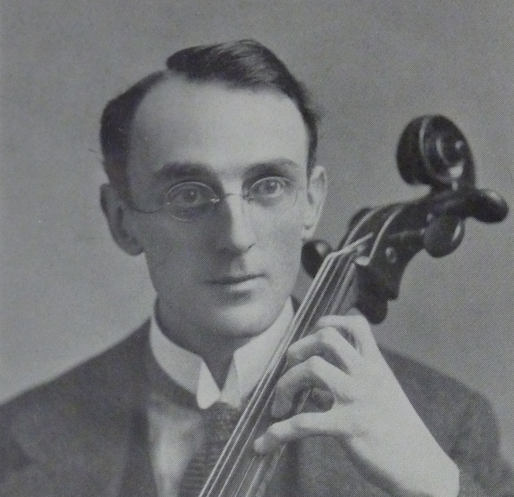
Joseph Schofield demonstrating his Method for Violoncello (London: Lafleur, 1923).
The most detailed information on Dublin cinema music and musician comes from the late 1910s, particularly following the launch of the Limelight in January 1917. The article referred to in the opening paragraph is particularly interested in the employment by the management of Dublin’s suburban Phibsboro Picture House of Joseph Schofield, “the very talented Dublin ’cellist, a musical prodigy who at the early age of 13 won the Baron Johann Von Knoop Scholarship at the London Guildhall School of Music, an honour which he successfully held for seven years against all comers.” In a sense, Schofield’s engagement by the Phibsboro Picture House demonstrates Fleishmann’s point: that good music – in this case, highly accomplished instrumental playing in the Western classical tradition – was not commanding enough of an audience in concert halls to provide Schofield with sufficient income as a professional musician, even when supplemented by his role as professor of cello at the Leinster School of Music. Therefore, since May 1916, he had been playing cello solos at Dublin cinemas, initially at the city-centre Pillar Picture House and latterly at the suburban Phibsboro. And his situation in early twentieth-century Ireland mirrored that of many other well regarded classical musicians.
If the virtuosic soloist had in the latter half of the 1910s come to represent the forefront of picture-house music, he or she – although it was almost always a man – did so by displacing from this position of prominence the women solo musicians or ensembles that had gained particular fame in the earlier part of the decade. By first favourably mentioning the woman musician Lily Fagan but then focusing at far greater length on Schofield, the Limelight article is emblematic of the evolving musical landscape in Dublin’s picture houses. By the end of the 1910s, a cinema musician might perform any of several roles. Schofield was playing solos, including some of the repertoire of forty he had composed himself, while Fagan was leading an orchestra that was “playing to pictures, [which] embraces something more than musical accomplishments. It requires from those who would succeed that subtle instinct for utilising music in a manner that creates a favourable atmosphere for each particular phase of the picture.” This was
perhaps the main secret of the marked improvement being shown by the Phibsboro’ Picture House Orchestra since it came under the able management of Miss Lily Fagin, a lady whose instinct in the choice of music is so unerring that, in our mind, it overshadows what are unquestionably remarkable accomplishments.
Little else is known about this phase of the career of Lily Fagan – the misspelling of her name here seemingly more than an editorial slip and becoming a sign of her partial erasure from the historical record. Not that Fagan is wholly obscure: newspaper articles show that she had received a commendation at the 1917 Feis Ceoil, the annual Irish festival of music, and in the 1920s and 1930s, she would lead Lily Fagan’s Ladies Orchestra and the Lily Fagan Trio, ensembles prominent at such major Irish festivals as the Royal Dublin Society’s Horse Show and Spring Show as well as on Irish radio. However, her job as the Phibsboro’s musical director – which her 1911 census return shows that she took up when she was still in her late teens – is known only through this tantalizingly brief mention in the Limelight.
Brief though it is, such examples of women working in cinema deserve attention to counter a previous neglect. Research focusing on women’s roles in the emerging cinema is the type of work being collated by such projects as the Women Film Pioneers Project and the Women and Silent British Cinema. It is also similar to work being done to recover the details of the lives of previously overlooked people as Ireland commemorates between 2012 and 2022 the centenaries of the events of the revolutionary decade that saw much of the country leave the United Kingdom. The commemorations of these events have been marked by a determination to acknowledge the role of women and other previously marginalized groups.
Although such political developments may seem remote from a discussion of the role that music played in cinema, they materially affected cinema in a variety of ways. For instance, when certain picture houses were among the businesses destroyed in Dublin city centre during the 1916 Easter Rising, landmark sites were cleared for the construction of the “super cinemas” of the 1920s. More directly related to cinema musicians, the use of military bands to provide accompaniment for the World War I propaganda films produced by the British and other allied governments from 1916 on demonstrated the ideological value of the identity of accompanying musicians. From an entirely different political perspective, films treating Irish historical topics from a nationalist perspective remained in circulation in Ireland for a long time and were often accompanied by popular Irish tunes. When the film Ireland a Nation (Macnamara, 1914) had its long delayed Irish debut at the Rotunda in January 1917, “Irish airs were discoursed by the orchestra while the film was being screened.” The Irish Times noted that the “film, which treated the rebel cause with sympathy, and the music, which included a number of Irish patriotic tunes, were received with loud and frequent applause by the audiences.”
Women musicians were playing in picture houses long before these mid-1910s political events. Music was a desirable career for young women in early twentieth-century Ireland. When in 1903, the Irish women’s journal The Lady of the House asked its readers what was their “highest ambition to be as a woman,” seven of the sixty-five respondents – a substantial proportion of those expressing ambitions outside the home – wanted to be musicians. When cinema emerged at the end of the 1900s, it provided several career possibilities. Although there were some women picture-house managers and jobs in ticket and refreshment sales were generally reserved for women, the largest number of skilled picture-house jobs available to women were as musicians. For both men and women, these increasingly professionalized jobs required the kind of extended education available only to the middle class. The growing prestige of cinema opened up possibilities for suitably trained women of this class who needed or desired an income but who were restricted from much paid work by barriers to the professions and by such nebulous controls as the discourse on respectability, which, for example, put the menial work undertaken of necessity by many working-class women beyond consideration – or at least, acknowledgement. As such, the increasing number of women cinema musicians is also an index of the increasing acceptability and even respectability of cinema itself, which these women were helping to foster by taking these jobs.
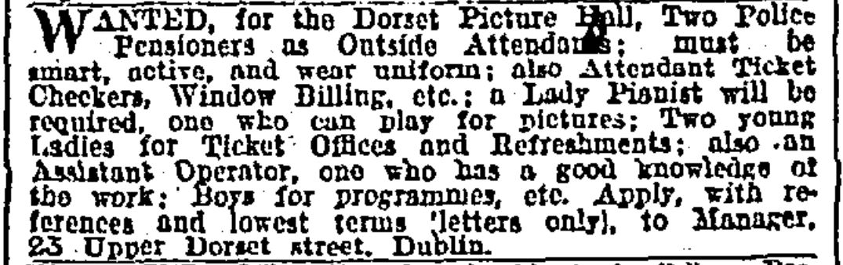
Dublin’s Dorset Picture Hall’s advertised for staff in the Irish Times, 20 March 1911.
Eva Hickie is the first identifiable woman musician who played for pictures in Dublin. In the Irish Times of mid-March 1911, Dorset manager William Shanly sought “a Lady pianist [...] who can play for pictures,” among other employees whose roles were also specified according to gender. The successful woman pianist was not identified when the Dorset opened in June 1911. Although Eva Hickie may not have been the only woman pianist at the Dorset between 1911 and 1914, she was later named as at least one of them by “Paddy,” the Ireland correspondent for the British film trade journal the Bioscope, whose column provides the most extensive information on Irish cinema before the appearance of the Limelight in 1917. “Eva Hickie,” Paddy reported, in April 1914, “late pianiste at the Dorset Picture Hall, Dublin, has accepted a similar position at Waterford.” The 1911 census lists just one Eva Hickie: the 25-year-old head of a household of five siblings and an aged servant, all of whom were living in Phibsboro, not far from the Dorset. As the occupation field of this Eva Hickie’s census form is blank, she must be added to the 979 Irish women who used the word “music” in the description of their occupation – the vast majority of them music teachers – and the further 94 who described themselves as musicians.
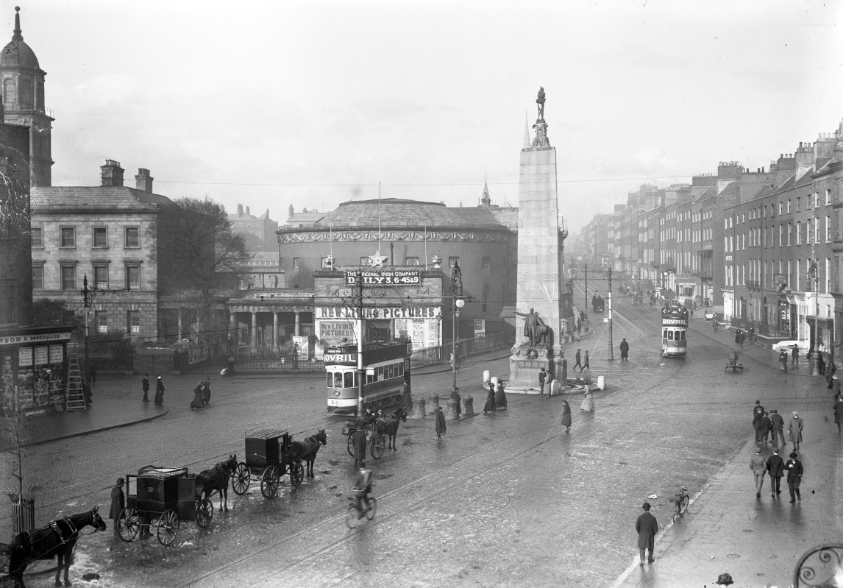
The intersection of Upper Sackville (now O’Connell) Street and Great Britain (now Parnell) Street showing the Rotunda Pictures, circa 1913. Courtesy of the National Library of Ireland.
Despite this lack of self-definition as a musician, Hickie in many ways resembled May Murphy, the most prominent woman musician in Irish cinemas of the early 1910s. The 1911 census puts both women in their mid-twenties and heading households of siblings belonging to the Catholic middle class, for whom music constituted one of the limited choices for respectable employment. However, Murphy appears to have been the more socially secure of the two, describing herself in the census – as did 75 other women – as a professor of music. Indeed, when first mentioned by Paddy in March 1912, Murphy was leading the Irish Ladies’ Orchestras at two venues operated by Ireland’s most important early film exhibitor, James T. Jameson: Dublin’s Rotunda and the Pavilion in Kingstown, Co. Dublin. The Rotunda was one of the city’s most prestigious entertainment venues, having been constructed in the late eighteenth century on a central site at the top of Sackville Street as a concert hall to fund the adjacent maternity hospital and thereby acquiring a connection with elite philanthropy. “A potent factor in the success with attends the pictures in the Dublin Rotunda Rooms and the Kingstown Pavilion,” Paddy observed,
is the Irish Ladies’ Orchestra, under the direction of Miss Murphy. In the Rotunda there are seven instrumentalists; in Kingstown three. Combined with the crimson and white colour scheme of their dresses, their little Zouave jackets complete a picture of dainty Bohemianism. Mr Jameson is to be congratulated on securing such a permanent attraction.
What inspired the creation of the Ladies’ Orchestra is not clear, but concerts by women’s orchestras – albeit rare – were by no means completely novel. Dublin theatrical audiences with long memories might have been familiar with such acts as Les Militaires, a 12-piece women’s orchestra led by Mrs. Hunt and wearing Hussar uniforms and tricorn hats that had visited the city in 1889. Fresher in the mind if less spectacularly dressed were two other women’s concert orchestras that played in the 1910s: the Mona (Welsh) Ladies Orchestra, which visited the Rotunda in 1910 – the timing and venue suggestive of influence on Murphy’s orchestra – and another Irish Ladies Orchestra – this one led by Muriel Jack – which toured Britain and Ireland in 1915. Nevertheless, the visual spectacle of Murphy’s Irish Ladies’ Orchestra’s dainty Bohemianism, which would be perfectly understandable in a theatre or concert hall, seems out of place in a picture house, where the audience should surely be focusing on the screen. However, audiences were expected to notice these musicians, a fact that indicates how the live musical portion of the programme was not just invisible accompaniment but was also a visual attraction.
Indeed, Jameson’s programmes at the Rotunda were renowned for their inclusion of live variety acts with the film programme. For example, the programme for St Patrick’s Day, 17 March 1913 included the films The Shaughraun (Kalem, 1912), Roderick’s Ride (Selig Polyscope, 1912), Broncho Billy and the Maid (Essanay, 1913), Bloomer Hurries Up (Cines, 1913) and Percy’s Express Deliver (1913), as well as a live act, “eccentric comedian” Bert Earle. Shot in Ireland the previous summer and based on a popular Irish play, The Shaughraun was the main attraction and was accompanied by “appropriate” but unspecified music arranged by Murphy for the Ladies’ Orchestra. What, if anything, Murphy had arranged to accompany the other films and Earle is not recorded.
Murphy’s role as musical director at both the Rotunda and the Pavilion was shortlived. Even as Paddy was asserting the permanence of the attraction, it was changing to offer an opportunity for another woman musician. Just a month after his announcement that Murphy was leading the two orchestras, he revealed that she had found it impossible to manage both the Rotunda and the Pavilion, located in a suburb 12km south of the city. Thereafter, Murphy focused on the Irish Ladies’ Orchestra at the Rotunda, and Jameson – “in no way minded to cut off the musical treat which the people of the Premier Township always expected” – employed a Miss D’Arcy to lead the newly renamed Pavilion Ladies’ Orchestra: “That Miss D’Arcy has succeeded in maintaining the high state of excellence for which the Pavilion has been famous in the past speaks well for her directorship and ability.”
These developments were of more than local interest. Vitagraph’s comic star John Bunny praised the Irish Ladies’ Orchestra and outlined the kind of benefits women musicians brought to the cinema. Bunny made his remarks on a working trip to Britain in 1912, during which he visited Ireland to shoot the short comedy Bunny Blarneyed, or The Blarney Stone (Vitagraph, 1913). “Women are always an immense power in the refinement of the world,” he remarked after taking in a show at the Rotunda. “The manager who, seeking to make his show suitable for all – from the little mites up – neglects this truth is only cheating himself of ultimate end. An orchestra composed of women is an undeniable asset to every hall in the world.” For Bunny – and for Paddy who quoted him favourably – such initiatives as the Ladies’ Orchestra put cinema at the forefront of respectable entertainment by putting women at the forefront of the cinema entertainment. There, they were visible signs and guarantors of a refined amusement suitable for all the family.
Although Jameson made a particular feature of his Ladies’ Orchestras, other women musicians were also well known to audiences, even when they were less visible during screenings. Miss Frazer, the pianist at the Pavilion’s rival Kingstown Picture House, garnered special praise for her beautiful singing during the run of The Badminton Hunt in January 1913 because “she did not sing from a platform, the film was not stopped at any time. Simply you heard her charming voice coming out of the darkened stillness at the piano.” Paddy also noted that May Louise O’Russ conducted the very able orchestra at the Mary Street Picture House.
For most commentators in the early 1910s, women musicians as visible signs appear to have been more important than the audible signs – the music – that one might think was their primary function. Although Dublin newspaper reviews of the Rotunda Pictures frequently included favourable comments on the Ladies’ Orchestra’s contribution to the entertainment, review writers did not say what they played, how much of the programme they accompanied, and whether or not they played before, between or after the films. One exception to this was the Dublin Evening Mail’s “Music and the Drama” columnist HRW, who on occasion commented at some length on Dublin cinema music. In autumn 1913, HRW detected changes in Irish cinema music that made him/her advocate “music of a neutral character.” S/he had recently heard this kind of music not at the Rotunda but from the orchestra directed by Jack Larchet at the Picture House, Sackville Street. “The music was all good,” HRW thought,
selected from the works of Rossini, Rubinstein, Tellier, and some modern French writers. There was no effort to illustrate the picture. Mendelssohn was not dragged in to celebrate a wedding, Wagner was not requisitioned to illustrate the astronomic beauties of the heavens, nor Grieg to depict the glories of the morning. There was nothing, in fact, to disturb, but rather tranquilise, the mind.
For HRW, the music was good because it did not illustrate what was happening on screen. It appears that Dublin picture houses were similar to London ones where, John Burrows argues, the synchronization of music with the action on the screen was not standard practice. To adapt Burrows’ argument: while it might have been possible for a skilled solo pianist such as Hickie to improvise suitably synchronized music for a programme of films she was seeing for the first time, it would have been very difficult if not impossible without significant rehearsal for a group of musicians such as Larchet’s or Murphy’s orchestras. As well as this, HRW was not in favour of pianists: “I have a horror of the lady who plays ancient waltzes and barn dances – indeed to engage a dance pianist at a cinema show is a crime. Players must be of a good class.”
A few weeks later, HRW clarified that whatever their other differences, Murphy and Larchet were not attempting to synchronize the music they played to narrative action; they were playing alongside pictures rather than to them. In October 1913, s/he compared some of Larchet’s and Murphy’s recent selections. HRW found that Larchet’s recent “dignified” choice of Mendelssohn’s Piano Trio No. 1 in D Minor and Schubert’s Unfinished Symphony to accompany Hamlet (Hepworth, 1913) exemplified the neutral music s/he believed represented the most effective accompaniment, explaining “that the selections should be broadly in sympathy with the general character of the film.” By contrast, HRW was not pleased by Murphy’s choice of songs used to accompany the factual film The First Irish Pilgrimage to Lourdes (General Film Supply, 1913), which Jameson had produced. The music provided by the Irish Ladies’ String Orchestra was “not only inappropriate but it was badly played. Gounod’s ‘Ave Maria’ was suitable enough if it had been well rehearsed, but Stephen Adam’s ‘Holy City’ and ‘The Star of Bethlehem’ are not sacred songs in the real sense of the word.”For HRW the crucial differences between the orchestras were the choice of appropriate music and how competently it was played for these very different films. However, “appropriate” meant a general suitability and not close correspondence between particular musical themes and phrase and specific onscreen action.
Regardless of HRW’s opinion, Murphy and the Irish Ladies’ Orchestra continued to feature at the Rotunda until shortly after the 1916 Rising (24-29 April). Indeed, the Rising seems to have been indirectly fatal to this phase of Murphy’s career. Located at the very top of Upper Sackville Street, the Rotunda was not significantly damaged by the fighting that took place further down the street. It reopened as soon as martial law restrictions allowed on Monday, 8 May 1916, with the press reporting that the Irish Ladies’ Orchestra “discourses a high-class musical programme.” However, much of Lower Sackville Street was completely destroyed, including the Grand Cinema. Rather than rebuilding the Grand, proprietor William Kay entered into a management arrangement with Jameson, and after a short closure for renovations, the Rotunda reopened in October 1916 under Kay’s joint management and with the Grand Orchestra replacing the Ladies’ Orchestra as the resident ensemble. Irish picture houses continued to engage orchestras of women after the demise of the Ladies’ Orchestra. In August 1920, Waterford’s Broad Street Cinema advertised in the Cork Examiner for musicians. “Pianist, violinist, ’cellist required,” the classified ad announced, adding “(ladies only).” Nevertheless, the need for women musicians as visible signs of cinema’s respectability appears to have diminished after 1913, and in 1915, the cinema soloist took the role of promoting cinema as a high-class entertainment.
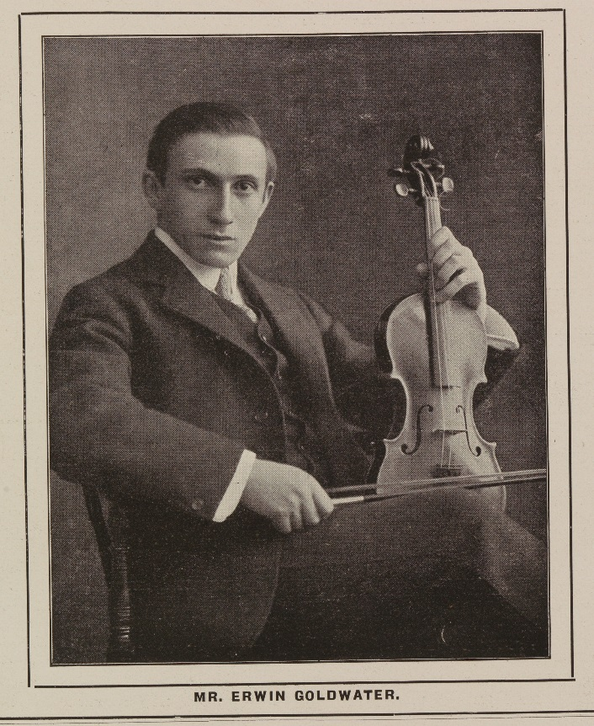
Portrait of Erwin Goldwater, musical director and soloist at Dublin’s Carlton Cinema; Irish Limelight, May 1917. Courtesy of the National Library of Ireland.
Ironically, a woman musician at the Bohemian Picture Theatre in Phibsboro appears to have been initiated this development in early December 1915. “The success attendant on the violin solos given by Miss M. Burke, a member of the Bohemian orchestra, during the performances of last week,” an Evening Telegraph reviewer revealed, “doubtless influenced the management to engage for the present week the services of Mr. Patrick Delaney, the celebrated violinist, who rendered at the 7 and 9 performances some delightful selections, which were warmly applauded by large audiences.” This Miss M. Burke is likely Mary Burke, who in the 1911 census described herself as a music teacher living in the nearby suburb of Drumcondra. Wherever Burke’s musical abilities, she clearly did not have sufficient celebrity. Although the Bohemian had attracted patrons since its opening in 1914 by advertising the city’s best musical attractions – consisting by 1916 of an orchestra of 16 musicians under musical director Percy Carver – it did not continue with this experiment in early 1916. Therefore, the recently opened and centrally located Carlton Cinema in Sackville Street introduced the concert soloist as a permanent feature by engaging violinist Erwin Goldwater. The Irish Times described Goldwater’s debut at the Carlton on St Patrick’s Day 1916 as “[a] new departure in connection with cinema entertainments [that] takes the form of a violin recital by Mr. E. Goldwater, a pupil of Sevcik, and formerly first violin at the Royal Opera, Covent Garden. Mr. Goldwater will conduct the orchestra at the Carlton.”
Goldwater’s appointment at the Carlton undermined the Bohemian’s long-made claim that it possessed Dublin’s largest and best picture-house orchestra. In April, however, the Bohemian engaged Clyde Twelvetrees – concert cellist and professor of the Royal Irish Academy of Music – to play as part of its daily programme. “Up to the present,” the Irish Independent commented, “if one wanted to hear a few famed soloists one had to attend the big concerts; but now one can hear the very best at convenience. Not to be outdone, the Pillar Picture House engaged, Joseph Schofield in April 1916. It was outdone, however, when just a month later, the Bohemian contracted a second soloist, the violinist Achille Simonetti. “Dubliners will keenly appreciate the enterprise of the management of the Bohemian Picture Theatre in permanently engaging the services of one of the most noted violinists of the day in the person of Signor Simonetti,” the Dublin Evening Mail observed. “Henceforth Signor Simonetti will act as leader of the Bohemian orchestra – which has won such a wide repute – and will give solos, as well as Mr. Clyde Twelvetrees, Ireland’s greatest ’celloist.”
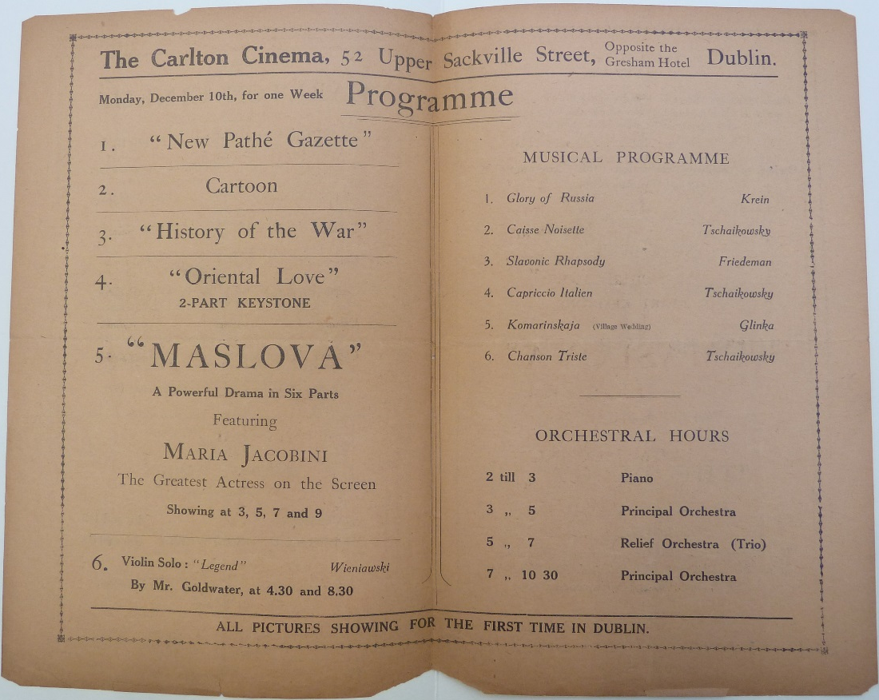
Programme for Dublin's Carlton Cinema for the week 10-15 December 1917. Courtesy of the National Library of Ireland.
Surviving programmes from Goldwater’s tenure at the Carlton in the late 1910s show how the soloist added a further musical layer to the cinema bill at Dublin’s most prestigious picture houses. The programme for the week of 10-17 December 1917 – when the feature was Maslova (Tiber, 1917), an Italian adaptation of Tolstoy’s The Resurrection – is particularly informative because it features not only the films and music played but also how the musicians changed during the day. Between 2pm and 3pm, a solo pianist provided music; the full orchestra took over for the first showing of Maslova at 3pm and played until 5pm, when the relief orchestra, a trio, played until 7pm, before the main orchestra took over again until the close at 10.30pm. Goldwater’s musical selections for Maslova were printed opposite the film programme. As well as this, at 4.30 and 8.30 each day, he played a violin solo, which that week was Henryk Wieniawski’s Légende.
In one day at the Carlton and Dublin’s other prestige picture houses in the latter half of the 1910s, a cinemagoer could experience the four kinds of playing alongside pictures that had emerged in the brief period of early cinema music. Music was played by turns by a solo pianist, a trio, a larger orchestra and a concert soloist. If it were at all true that the Irish were an intensely musical people, as the Limelight claimed, then the advent of the picture house had provided them with quality music in a readily accessible form.

“Music and the Movies,” Irish Limelight 2, no. 6 (1918), 4.
Aloys Fleishman, “Music and Society, 1850-1921,” in A New History of Ireland, IV: Ireland Under the Union, 1870-1921, ed. W. E. Vaughan (Oxford: Oxford UP, 1989), 517.
Jon Burrows, “The Art of Not ‘Playing to Pictures’ in British Cinemas, 1906-1914,” in The Sound of the Silents in Britain, eds. Julie Brown and Annette Davison (Oxford: Oxford UP, 2013), 123.
Morgan was mentioned frequently in reviews; in ads in March 1910 (e.g., Irish Independent, 7 March 1910), his orchestra was said to be playing music provided by the popular-music publisher Francis, Day and Hunter. On the Phonoliszt-Violina, see auctioneer’s ads for the sale of the first Volta’s effects, Freeman’s Journal, 15 June 1910.
“Music and the Movies,” Irish Limelight 2, no. 6 (1918), 4.
National Archives of Ireland, Census of Ireland 1901/1911 and Census Fragments and Substitutes, 1821-51, 2007, www.census.nationalarchives.ie, accessed 28 December 2016.
Jane Gaines, Women Film Pioneers Project, wfpp.cdrs.columbia.edu, Columbia University, 2013, accessed 31 December 2016; Clare Watson and Nathalie Morris, Women and Silent British Cinema, womenandsilentbritishcinema.wordpress.com, 2007, accessed 31 December 2016.
Denis Condon, “Temples to the Art of Cinematography: The Cinema on the Dublin Streetscape, 1910-1920,” in Visualizing Dublin: Visual Culture, Modernity and the Representation of Urban Space, ed. Justin Carville (Bern: Lang, 2014), 133-54.
“Irish History Films: ‘Ireland a Nation’ at the Rotunda,” Freeman’s Journal, 9 January 1917. On the film’s delayed Irish debut, see Condon, Early Irish Cinema, 1895-1921 (Dublin: Irish Academic P, 2008), 198-202.
“Rotunda Pictures,” Irish Times, 9 January 1917.
Stephanie Rains, “Irish Women Freelance Writers and the Popular Press: An Army Beyond Literary Circles,” ELT 60, no. 1 (2017), 52.
Paddy, “Pictures in Ireland,” Bioscope, 16 April 1914.
Paddy, “Pictures in Ireland,” Bioscope, 14 March 1912
Eugene Watters and Matthew Murtagh, Infinite Variety: Dan Lowrey’s Music Hall 1879-97 (Dublin: Gill and Macmillan, 1975), 109-10
“Platform and Stage,” Irish Times 15 March 1913.
Paddy, “Pictures in Ireland,” Bioscope, 25 April 1912.
Paddy, “Pictures in Ireland,” Bioscope, 12 September 1912.
Paddy, “Pictures in Ireland,” Bioscope, 30 January 1913.
HRW, “Music and the Drama,” Dublin Evening Mail, 22 September 1913.
Burrows 113.
HRW, “Music and the Drama,” Dublin Evening Mail, 13 October 1913.
“Public Amusements: Rotunda,” Irish Times, 9 May 1916.
Paddy, “Ireland: With Renters and Exhibitors,” Bioscope, 19 October 1916.
“Bohemian,” Evening Telegraph, 7 December 1915.
“Platform and Stage,” Irish Times, 18 March 1916.
“Dublin and District,” Irish Independent, 22 April 1916.
“The Play’s the Thing,” Dublin Evening Mail 10 June 1916.
Trevor Griffiths reproduces a very similar table of orchestral hours for musicians at Edinburgh’s Palace Cinema in 1916 in “Sounding Scottish: Sound Practices and Silent Cinema in Scotland,” in Brown and Davison 75.

