Land Redistribution in Ireland 1923-1960

A study of the Irish Land Commission

Case Study of Kilmacredock Co. Kildare

Submitted by
Suzanne M. Pegley

Supervisor
Patrick J. Duffy

Dissertation submitted in partial fulfilment
of the requirements of the
BA Honors Degree in Geography
Department of Geography
NUI Maynooth 2004
Abstract

This dissertation is in part an examination of the mechanisms of the Land Commission in the application of the Irish land policy and demonstrates the attempt to create in the Irish countryside a rural idyll. Part of the dissertation will also examine the migration policy that evolved in the early years of the state and will use as a case study the migrant group who came to Leixlip Co. Kildare.

During the latter years of the nineteenth century the land-distribution policies to deal with the Congested districts of the west of Ireland were put in place. The Land Commission was created in 1881 functioning as the agent through which land was purchased and redistributed to allottees.

With the independence of Ireland, the Irish State continued the principal of land-distribution. In a report to the then government in 1923, the Gaeltacht Commission suggested that land in the congested districts might be exchanged for land elsewhere in the west and more radically for land in the east. This study explores the widespread clientelism by the Fianna Fail Party in generating political support and together with the vision of Eamon De Valera the creation of an Arcadian rural society.

A case study of a townland in the east, Kilmacredock, County Kildare demonstrates the impact of these land-distribution policies. This impact is manifest for the migrants by the need to reshape their identity and a sense of place on their arrival in 1959. In the 21st century changes to the urban rural fringe have created further change in the townland with the growth of the city into the hinterland. The new houses, the motorway and attendant exchanges have surrounded the townland and further change will inevitably come.
Acknowledgements

There are many individuals who deserve to be acknowledged in their contribution to the writing of this dissertation. First, I would like to thank Patrick Duffy who made a number of helpful suggestions that I was able to follow up on. Many others were simply part of the fabric of university life and generously gave their friendship and support as part of their daily lives. In particular the library staff are the face of the university and their willingness to interact with the students is of major importance.

There are several people I would like to single out for thanks. During the writing of this dissertation Sheila Smith an undergraduate of the Sociology Department was working on a thesis in a similar vein concerning the migrants of Co. Meath. It was lengthy hashing out of ideas between the two of us that has shaped my approach to this dissertation. I wish to convey my thanks and appreciation. Two others were very helpful, Dr. Terrance Dooley spoke to me of the difficulties I would face and made a number of recommendations and added a generous dollop of encouragement. The second and quite unexpected individual is David Jones whom I met in the National Archives. We began to talk as strangers do and he offered suggestions and pointed me to his book and articles. Most importantly he agreed that the approach I was taking to the topic was valid.

In Kilmacredock the people I interviewed were so very generous and co-operative with their time. I would like to thank in particular Eileen Lennon, Nora Hopkins and especially May Keir O’Brien for acting as the ‘gatekeeper’.

I would also like to thank both Patricia Donohoe and Brendan Twomey for reading early drafts of this work and offering suggestions.

I also have to thank my family, especially my husband Charlie who intriguingly mentioned ‘the migrants’ and ‘the mucky lane’ in 1970 when I originally came to Leixlip, because they are the ones who do without while we scribble incessantly for months.

Finally, one cannot forget the daily interaction with one’s fellow students. Without the group always willing to listen and to be listened to in return university would not have been such a fruitful place.

Thank you to you all.

Table of Contents

Abstract 1
Acknowledgements 3
Table of Contents 4

Introduction 6

Literature Review 7

Methodology 10

Chapter One: The Colonial Period 12

Chapter Two: The Influence of Fianna Fail 21
The Famous Speech 25
Independence and the Division of Land 28

Chapter Three: The Case Study of Kilmacredock, Co. Kildare 37

Conclusion 51

Bibliography 53

Appendix One: Summary of Colonial Land Policies 58

Appendix Two: Statistical breakdown of land-distribution
1881-1922 and 1923-1978 including 1979-1982 60

Maps
Fig. 1.1 Map of Congested Districts 16
Fig. 2.1 Uninhabited areas of Ireland 29
Fig. 3.1 Location map of Kilmacredock, Co. Kildare 37
Fig. 3.2 Location map of Rossaveel, Co. Galway 40
Fig. 3.3 Rossaveel, Co Galway 41
Fig. 3.4 3.5 Kilmacredock, Co. Kildare with overlay 43

Plates
  - Land Commission Payment Sheet 17
  - A typical house in the Congested Districts
Monivea, Co. Galway. 19
  - An improved holding in the Congested District
Monivea, Co Galway. 19
3.1 Saving the hay, Kilmacredock late 1960s 45
3.2 The original home of the Lennon family, Kilmacredock 47
3.3 Typical Land Commission house similar to Lennon’s new 47
House.

Land Redistribution in Ireland 1923-1960

A study of the Irish Land Commission

Case Study of Kilmacredock Co. Kildare

Introduction
The populist Fianna Fail Party, when they came to power in 1932, in their desire to create a society with a predominantly rural focus continued the redistribution policies begun by the British government. In 1923 the Irish Free State having taken over the established Land Commission formed in its image the Irish Land Commission (ILC) and legislated for this body great power to enact their policies. The original redistribution policy, beginning in the late nineteenth century, was intended to relieve congestion in the west through the purchase of the estates of the landed classes. Various problems arose not the least of which was the Easter Rising of 1916. Following independence, the defacto Irish government attempted to continue the work begun previously. A more far-reaching migration concept was suggested in 1925 by the Gaeltacht Commission, that of exchanging the land of individuals in the congested districts of the west for land elsewhere in Galway, Mayo and Roscommon or in the eastern counties of Kildare, Meath, Westmeath and Dublin. (Nolan 1988:307) While not initially received with enthusiasm by the ILC this would later take the form of colony and group migration schemes.

The relevance of the land policies of the early twentieth century for today is the romantic relationship urban populations have with the rural countryside. With the growth of the urban centres people are visiting and moving into the countryside in search of the tranquillity they have dreamed about and have been taught to believe in. This has had far reaching effects on the farming communities, particularly those close to the urban rural fringe, not alone in their relationship with their occupation, but with the new residents in their spatial environment. This topic and the policies of the Fianna Fail party will be addressed in conjunction with the Land Commission with the use of a case study of a townland near Leixlip, County Kildare.
In chapter one I will show the historic and economic circumstances that led to the land acts of the late nineteenth century. In chapter two the influence of Eamon De Valera and the Fianna Fail party is explained in the continuing development of the Irish Land Commission. Finally chapter three is a case study of a Kildare townland and a group of migrants who came from the west of Ireland in 1959. This chapter will also consider the development of identity and a sense of place.

Literature Review
Embarking on a topic of research requires one to have a number of questions. Initially the questions that prompted this dissertation were quite simple. What exactly is the Irish Land Commission, how does it work and why is it such a big secret? As I pursued my task other ideas began to emerge. How were the policies of the new government tied in with the development of the nation state? If the ILC was a government body then how did the government control it and how did it become an agent for government policy? It was a passing remark by Dr. T. Dooley, of the History Department, who said, “the Land Commission migration policies were a social manipulation on an unprecedented scale” that prompted me to look at the social policies of the young independent state. There is however a problem, this is a rather new area and very few researchers have written on the subject.
Without a body of work to call upon it has been a question of looking at anything I could find about the political structure of the early years of the Irish State for any mention of the Land Commission. A number of books were helpful in throwing light on the ethos of the newly independent state. In particular The Dynamics of Irish Politics by Bew, Hazelkorn and Paterson and Fianna Fail and Irish Labour by Allen. These showed the historic development in the 1920s, 30s, and 40s of independent government. They demonstrated that the land question was of vital importance, above even the boundary dispute. Two more gave an insight into the labyrinthine workings of the Land Commission and the land acts, which drove the land redistribution. Patrick Sammon’s book In the Land Commission: A Memoir 1933-1978 was most useful for his appendices, which included a number of speeches by Ministers for Agriculture. The second, Readjustments of Agriculture Tenure in Ireland by Elizabeth Hooker was the most valuable in explaining the activity of the Land Commission and Irish Land Commission in a straightforward manner. It was originally intended as a study of the accomplishments of land redistribution in Ireland, for possible adoption in America. It explains clearly the advantages and disadvantages of the system as Hooker interpreted it. I have referenced Ms Hooker extensively in this study. For a background to the early development of the Land Commission under the British Government Land Reform in Ireland by Kolbert and O’Brien was enlightening as to the legal history of the Irish land problem and its resolution and offered an insight into events in the nineteenth century. This prompted me to consider the impact of the agrarian aggression in driving the resettlement and redistribution of lands. In considering De Valera’s idealistic contribution to the rural society he was in many ways creating, R.V. Comerford’s book Inventing Ireland confirmed many ideas concerning the rise of nationalism. The book by Moynihan of De Valera’s speeches and statements presented the famous comely maiden’s speech and showed the development of his view of the Irish State. Tovey and Share’s book Sociology of Ireland provided the theoretical background to aspects of the development of polices. They asked and provided many possible answers as to who oversaw the change and development in Ireland’s agricultural and industrial development. They also explored the connection between nationalism and the land, which is touched upon in a number of other miscellaneous readings recorded in the bibliography. With the migration of people from west to east I found a geographical grounding in Ann Buttimer and D. Seaman’s book The Human Experience of Space and Place and Paddy Duffy in Doing Irish Local History. Both offered an insight into how the creation of a new farming community lead to an equally new formation of identity for those who came to live in Kilmacredock.

This dissertation has been a challenge because there has been so little direct writing on the subject of land redistribution and the migration of people. It was necessary to take my ideas and attempt to see how the work of others could be applied to the subject of migration. It is I feel a topic that is waiting to be fully explored, both geographically with the new space and place theories and sociologically, to examine a unique manipulation of the fabric of Irish society.

NOTE: 2022
See ‘The development and consolidation of Rath Cairn, Co Meath: The first Gaeltacht Colony’ an unpublished MLitt thesis by Suzanne M. Pegley, 2007 NUI Maynooth.
Also The Land Commission and the Making of Rath Cairn the first Gaeltacht Colony by Suzanne Pegley (Dublin, 2011).

Methodology
The background to this essay has mainly involved reading about the early years of the state. This not only consisted of the books shown above but the Land Commission annual reports in the National Library published by the Department of Agriculture. Some time was spent examining the cabinet minutes in the National Archives for comments or items concerning the migration policy. I pursued for two months a report about the Migration Policy for the years 1939 to 1942 delivered to the Cabinet. In this unsuccessful search the main repositories were visited more than once and numerous phone calls were made but it remained elusive. For the case study of the townland of Kilmacredock close to the village of Leixlip Co. Kildare the main Dublin repositories were also used. The National Archive was the source for the Census records for 1911. The ‘Cancellation books’ in the Land Registry at the Irish Life Centre were consulted concerning the acquisition of the lands at Kilmacredock. I have collected and drawn a number of maps to illustrate and explain the points made in the paper. The comparative use of maps is a valuable tool in understanding land redistribution. They were obtained from The Map Library at Trinity and the Geography Department at NUI Maynooth and various books. Photos of the Congested Districts were obtained from the National Photographic Archive and photographs of the townland were taken for the case study. Finally, I was able to meet and interview three people who had been in the original migrant group to Kilmacredock.

The difficulty I encountered and one that I had been aware of from the beginning was that the Department of the Irish Land Commission is a working department and is closed to research. (This is apparently not strictly true as I encountered David Jones surrounded by ILC material in their anti-room.) This means of course that one cannot, certainly as an undergraduate, conduct any actual research on specific material. I did not even attempt to figure a way around this problem, as it would have required too much time for an undergraduate piece of research. In the future as a postgraduate it might be possible to obtain access as Jones has done.

Chapter One: The Colonial Period
Due to economic and social forces the population in Ireland had begun to rise in the late eighteenth century and peaked, at eight million, by 1840. What were those forces and how did they lead to the radical land reform that had begun to occur by the closing decades of the nineteenth century?

In the latter period of the eighteenth century, by supplying the British army with food, particularly during the French wars, commercial farming was flourishing. The buoyant economy in both England and Ireland led to greater prosperity and had a positive effect on the Irish peasantry. The growth in the market economy since 1780 (McCourt 1981:122) principally of tillage crops created an abundance of work for labourers. This in turn led to early marriage and as a consequence an increase in the population.

Commercial farming however had a negative side, manifest in the competitive rents demanded for good land. As a result, expanded production was required for both the market forces and for profit margins. Every available parcel of land was put into productive use even wasteland was reclaimed. Cottiers and labourers living in areas of commonage or rundales were forced into enclosed lands, as were lands in other parts of the United Kingdom. Some in the remoter areas of the West resisted and formed claghans. These villages or quasi communes consisted of farmlands held in common. The lands varied in quality and were assigned on a yearly rotation to the families within the community. By the 1820s, with the increase in population, each claghan contained twenty to thirty houses. (Slater 2003) The associated lands were sub-divided into smaller and smaller allocations, some of five acres or less. The rent, an accumulation of each family’s contribution was paid to the landlord in cash. This arrangement represents a classic example of Irish feudal rent relationship. (Slater & McDonough 1994)

After the end of the Napolionic Wars in 1815 there was a radical shift in agricultural production. The labour intensive tillage, was swept away to be replaced by cattle production. Once again, the pressure was on the rundale or shared commonage. The landlord wanted his tenants on single occupancy holdings. Large land areas were needed for the new ranch style cattle farming. It was also judged that single occupancy would eliminate wasteful fragmentation of both good and poor land.

The population had peaked at approximately eight million by the 1840s. This resulted in an increase in tensions regarding the rent relationship between the labourer, cottier and landlord. In Ireland with a considerable number of absentee landlords the practice of subdivision of land by the large tenant farmer was common. This created a sub tenant class that existed on the marginal lands that provided a minimum subsistence level. As the Census of 1841 revealed the population was increasing beyond the carrying capacity of the land, a situation predicted by Thomas Malthus. Coupled with this was the increasing tendency by the landowner to claw back some of the rents from the middlemen and larger tenants. As a result, evictions began to increase. Following the Great Famine of 1845-49, not only had a great many people been lost but a feudal system of land tenure was swept away. (Slater & McDonough 1994) While there had been a growing call for security of land tenure, following the famine this became an even more urgent demand.

In the second half of the nineteenth century Ireland underwent a major upheaval where land was concerned. Part of the change of attitude post famine was the realisation on the part of tenants that their relationship to the land had to change. Articles in the Freeman’s Journal (7-9 August 1850) show that socialist thinking was entering the equation through the demand for shared profits of cultivation. After the famine, with the breakdown of the feudal system of land and tenant relationships, the agrarian movements begin to form.

As if the famine wasn’t enough hardship the decades afterwards were not ones of recovery. To begin with the years following the famine were one of agricultural plenty, however the seeds of future destruction were sown. With the optimism of recovery and with no eye to the future the great landowners over mortgaged their properties and with this money rebuilt, redecorated and embellished. By the early 1860s they would be looking to the government for help. (Dooley: 2001)

After the short-lived buoyant beginning by 1859 an agricultural slump had occurred that was to last for five years. During that period land agitation from the steadily rising Catholic population was becoming problematic and would ultimately lead to the intervention of the government. In particular the cottier class, slowly recovering from famine, put demands on Westminster, for an equal share of their own land. As the agricultural depression deepened landlords became harsher toward their tenants, and resorted to pre famine style eviction. As a result, greater numbers of tenants formed tenant associations and farmers clubs. These eventually amalgamated into the Tenants Rights Association forming a political and economic platform. (Cronin 2000) This political pressure group demanded what was know as
The Three F’s:
Fair rent legally regulated.
Fixity of tenure after rental payment.
Free sale, allowing outgoing tenant to sell his interest to incoming tenant
As these issues became the subjects of popular agitation and electoral politics, the farming community, farmer, grazier, cottier and labourer became more politically aware. Part of the growing difficulties were the needs being voiced and acted out by the early land leagues.

In 1870 the British Prime Minister William Gladstone bowed to pressure and introduced a land bill that recognised the three F demands. This land bill and other Land Acts brought in through out the late nineteenth century and into the early twentieth century were an assault on the political power of landlords and were to change the face of Irish society.

The agricultural depression of the late 1870s, coupled with the world-wide depression took from the already vulnerable farmer any hope of a return to the prosperity of the mid-1850s. Cattle prices declined and tillage output was reduced by a series of disastrous seasons. Connaught, the most seriously affected initially broke out into agrarian outrages but then focused its energy into forming the Land League.

The Land League made up of strong farmers, small to middling farmers and labourers, at first mobilised into a common cause. It was not long however until a contradiction of priorities among the different types of farmers emerged. Smaller farmers of the west demanded their own land and the break up of the large cattle ranches. The larger cattle ranchers demanded in their turn a reduction in rent.

In response to this overwhelming agitation the British government commenced to introduce a series of Land Bills that would improve on the earlier land act allowing for the purchase of lands by the sitting tenant and purchase of the great estates by the Land Commission. This process became known as land redistribution. It was at this time that the original Land Commission, the Estates Commission and Congested Districts Board (CDB) were set up. (Fig.1.1).

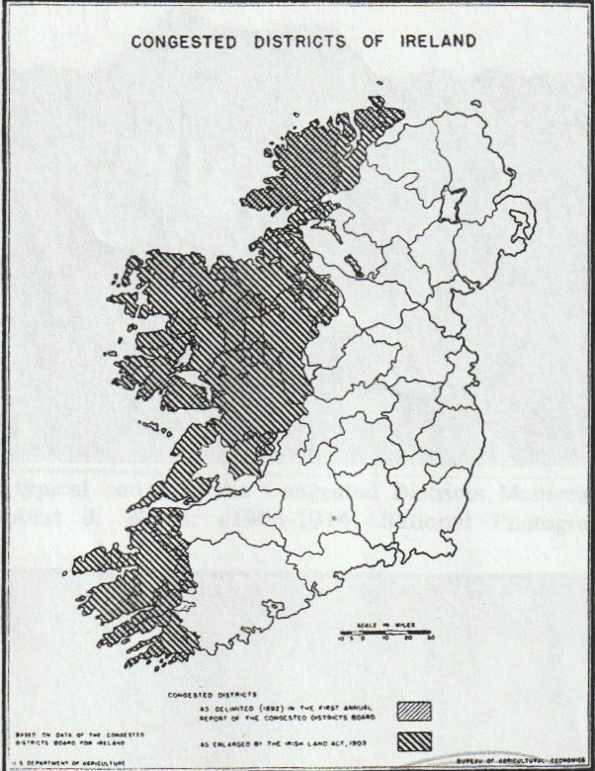
Fig. 1.1 Congested Districts of Ireland (Hooker, 1938)

The role of the Estates Commission within the Land Commission was to administer land purchase, leading to the relief of congested districts. During this period 195,000 tenants purchased their holdings in the 26 counties. (Kolbert & O’Brien 1975) The regular half-yearly repayments were recorded on Land Purchase Account payment sheets and stamped accordingly. (Plate 1.1)
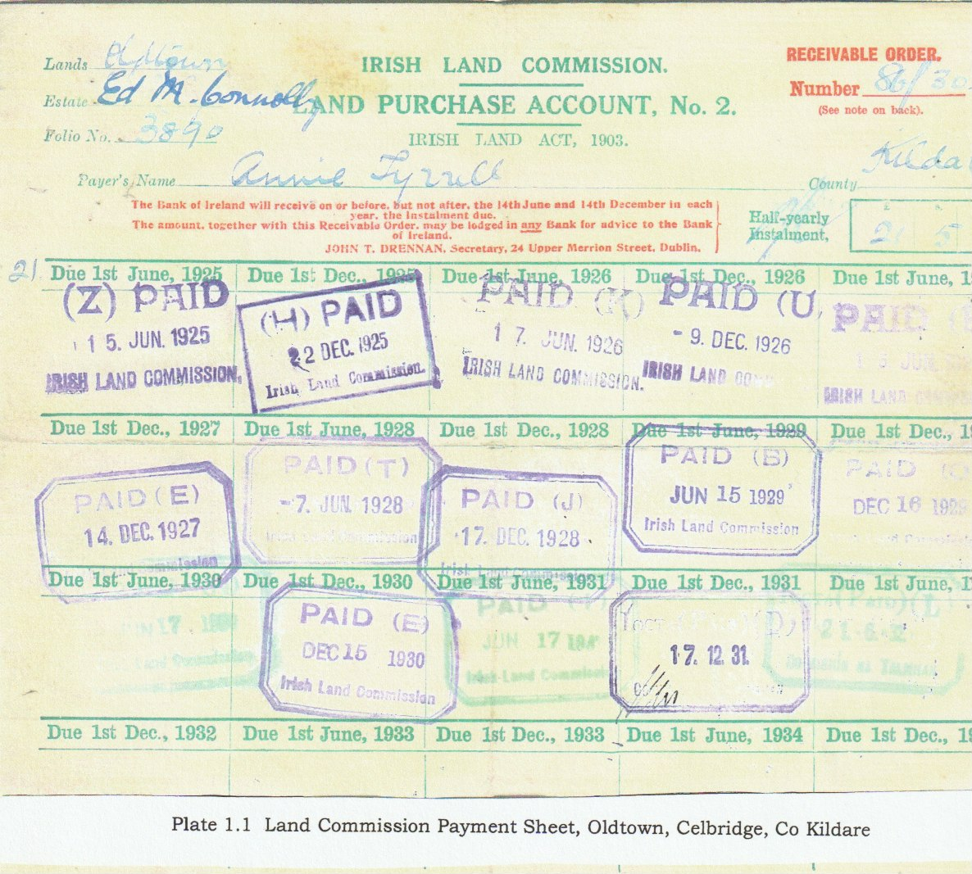
The CDB at this time consisted of eighty-four districts, about one sixth of Ireland. The congested districts typically consisted of fifty or so mini holdings huddled together in claghans aggravated by the rundale system so prevalent in these quasi communes. (McCourt, 1981) To determine what district is classed congested, the criteria were where more than 20% of the population of an electoral division where the total rateable value, when divided by the population, comes to less than £1-10s. In the Land Act of 1909 this included all of Donegal, Sligo, Leitrim, Roscommon, Mayo, Galway, and Kerry and portions of Clare and Cork. (Fig. 2.1) (Hooker1938:127-9)

It must be stressed that land redistribution was not simply a handing over of a new holding to a new tenant, it also included an improvement of the holding. This improvement consisted of a new house, outbuildings, stock and general up-grading of the land as well. To ensure good farming practice an agricultural advisor would also call regularly. (Plates 1.2 & 1.3)
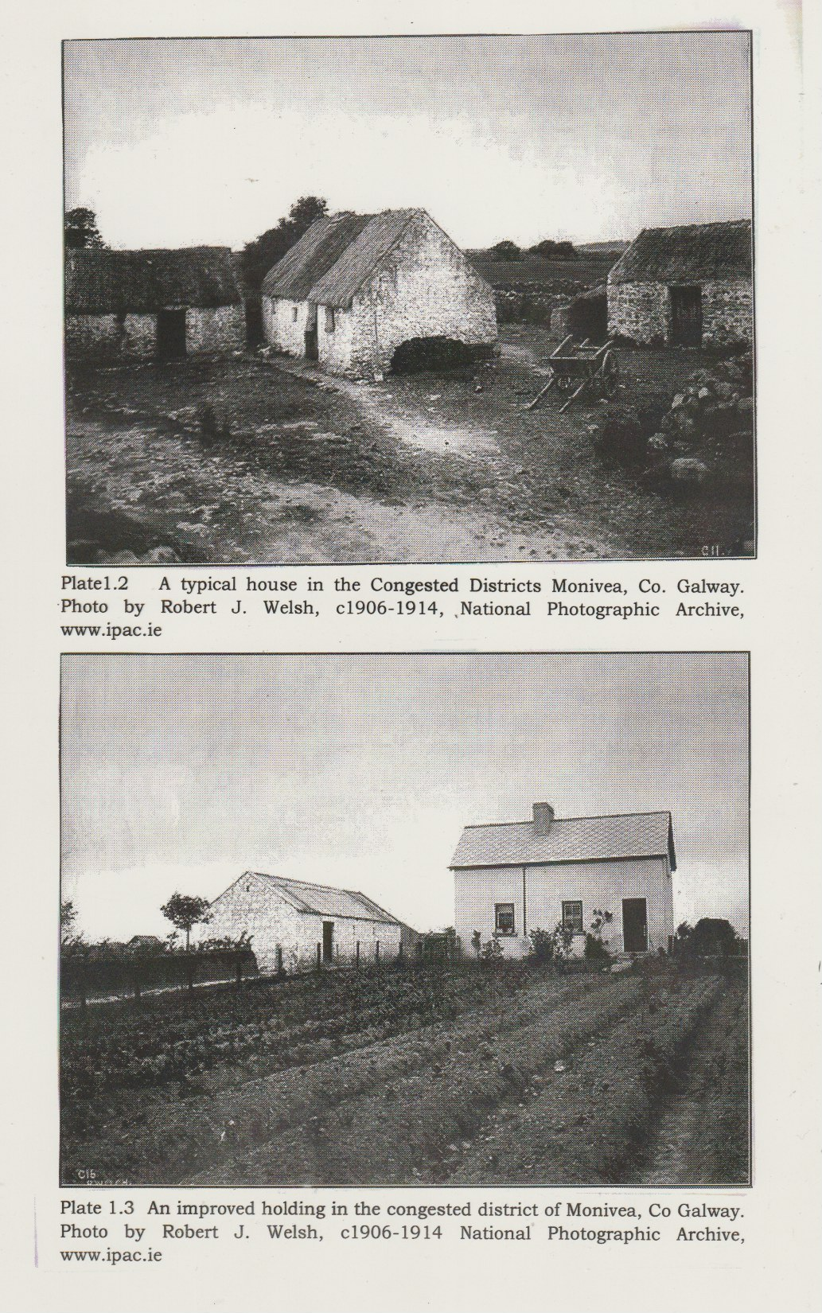
While the financial plight of the great land-owning class is viewed unsympathetically it was their willingness to sell as a way out of their own financial problems. That then allowed the colonial government to deal with the overwhelming poverty and overcrowding of the Congested Districts. Paid in Land Bonds some landowners never received the value of their estates because of the falling value of the bonds. By 1923, when the Irish Free State was initially set up, marking the end of direct colonial rule, some 750,000 acres had been distributed.

Chapter Two: The Influence of Fianna Fail

The land question as it was euphemistically called is inexorably bound up in the rise of nationalism. The invention of Ireland surrounding the tension filled period of the late nineteenth century and early twentieth century is one in which the land played a pivotal role. From the late nineteenth century and later under the influence of Sinn Fein the spirit of Nationalism became very strong. (Hooker 1938:90)

Colonialism imposes upon a country direct political control and in terms of the Irish experience it has critically shaped society and culture. Through the agency of the British Government, beginning in the second half of the nineteenth century Ireland embarked on a process to intellectually separate from the colonial mentality. (Ruane1992:293) Throughout Europe at the same time countries were undergoing a move toward individual national identity. (Comerford, 2003) In the early years of the newly independent Irish State the overriding political focus was the use of land as the agent for the rise of Nationalism and Republicanism. Still, nationalism was for many linked not with an independent Ireland but Irishmen in control of their own lands and having equal rights within the United Kingdom. According to James Connolly the era of capitalist farming was ushered in by the British government reforms responding to the demands of the Land League.

In newly emerging modern states, the state itself plays a major role in the transformation of ‘traditional’ society into a ‘modern’ one. (Tovey & Share 2000:73) Globalisation theorists of the late twentieth century throw light on the responsibility of the state in the early years of independence. They argue that in semiperipheral and developing societies the state plays a pivotal role. This was in part an attempt by the Irish State to define for themselves what exactly it was to be Irish. The development of various institutions to make up the nation state was an important step. (Tovey & Share 2000:79) Historically Irish leaders had used the desire for land as a rallying point. From the abstract ideas of Home Rule where “Irishmen would rule Ireland” to the more concrete ideas of the Land League and the rent reduction issues.

One of the most important mechanisms for the introduction of the emerging Irish State was the Irish Land Commission. By encouraging the land question to drive the political dynamics onward the various Land Acts not only exceeded to the demands of the Land League and their supporters it allowed the Land Commission to have greater powers to acquire and redistribute land.

From the end of the famine until the establishment of the Irish Free State the struggle both spiritually and actively was the attempt to enfranchise the vast numbers of tenant farmers as owners of their own lands. Once the concept was established the impetus was continued with the evolving Irish government known first as the Irish Free State (IFS) then Saorstat Eireann and finally Ireland or the Republic of Ireland. (Comerford 2003)

The country at large was caught by surprise by the 1916 Easter rising and was not initially disposed to support it. Independence was a new concept to most but as history shows that support soon followed. As Sinn Fein emerged through popular support it stimulated a patriotic love for the soil of Ireland (Hooker 1938:162) and Nationalism was beginning to focus on rural society. The attempt by the British government to alleviate congestion resulted in a growing distrust and irritation of the farmers in the congested districts. In particular the small farmers of the west were where the Fianna Fail (FF) party would later find their strongest support. In response the de facto emerging Irish government set up three agencies to deal with land problems.
Land Settlement Commission
Land Courts
Land Bank

How a newly emerging state chooses to develop its favoured projects is strongly influenced by its own history and by the various groups that played a part in its construction. Fianna Fail when they first came to power in 1932 were credited with a smooth take over by accepting the established system of government that they had inherited from the colonial power. Any late modernising state however must imitate the colonial state and act as the bourgeoisie class. This was not a question of choice the underdeveloped state must restructure the economy in the direction of the core society to maintain stability. (Tovey & Share 2000:74) Ireland, despite De Valera’s attempt to deny reality was caught in the classic dependency theory. In the background the Fianna Fail Party were placing in positions of influence ex-IRA men to ensure loyalty to Fianna Fail policies. Never-the-less it is suggested that less obvious powerful interest groups control the state. (T&S 2000:84) One can see how the agricultural classes, made up of the large landowning graziers and the large demographic of small farmers who were powerful enough to drive FF policy.

These ex-IRA appointments were eventually addressed in 1935 with the appointment of a representative to handle government appointments and other matters. Underlying the various appointments, pensions to ex-IRA and redistribution of land to the landless was to ensure loyalty. The enduring loyalty to FF up to the present is evidence that this strategy has worked. The 1930s proved to be the most favourable decade for the establishment of influence.
‘...the party had an acute appreciation of how the state could be used in an underdeveloped country.’ (Allan 1997:44)

The rural farming society despite the moderate successes of the various land acts already outlined, remained separated by privilege and poverty. The wealthy grazing farmers, many of who were Irish Catholic and not the Anglo-Irish Protestants as much of the popular rhetoric would have us believe. Ranchers held individually often 400-600 acres and more. On the other hand, small and medium size farmers and the landless felt they wanted a share of these untenanted grazing lands.

While certain political posturing against the highly capitalist grazier did go on, in reality these farmers were the backbone of Irish farming. The export trade in livestock represented 95% of GNP in 1926. To break up the big ranches for redistribution would have spelt economic disaster for the agricultural sector. Fianna Fail was forced to walk a fine line between the clamour by the small and medium farmers and the landless and the reality of economics. It could not adopt policies that appealed to the poorest of the farming society in the west of land redistribution without alienating the strong farmers of the south and east. (Bew et al 1989:43) In the economic reorganisation of the 1930s the move to rid the country of all but Irish goods and become self-sufficient, lead to further conflict with the large graziers who were intent on continuing the agro-export to the United Kingdom. (Allen 1997:61) Ultimately it was recognised that this trade was vital and the cattle-coal link would be agreed in 1938.

The ‘comely maiden’s’ Speech: St Patrick’s Day, 1943
It may be difficult to appreciate today the cult of personality surrounding Eamon De Valera but for the period of the early state development he was Ireland. It was his political will that drove the ethos of the government of the time whether in or out of power. What he said or did was sooner or later reflected in the agency of government. In 1942, the year before this speech was delivered; De Valera was urging the Land Commission “to take up as a matter of urgency the maximum achievement possible in land division”. (Jones 2001:91)

Eamon DeValera’s “comely maiden’s” speech was intended to urge the population to learn and speak Irish but more memorably in this speech is his vision of Ireland. By the 1940s when this speech was broadcast for St Patrick’s Day, on Radio Eireann, Ireland had undergone considerable agricultural change. What the IFS government and later FF policies had established was a format that attempted to create the vision he described and that has coloured the perception of Ireland up to the present day.

The first paragraphs are filled with the language of high spiritual rhetoric. The Gaelic League, for whose 50th anniversary this speech was directed, had expended great efforts to restore the Irish language. The league was among the most powerful influences in the revival of the national spirit after the downfall of Parnell. (Moynihan1980:466) We are familiar with many of the often-quoted passages but as a result they have lost their initial impact. Delivered in 1943 at a time when the Second World War was well established, it put into words the feelings of a recently independent country struggling to find its place in the community of nations. It encapsulated much of what were the theories behind the Land Acts put in place since the founding of the state. For this reason, I believe it is worth quoting the first few paragraphs.

Before the present war began, I was accustomed on St. Patrick’s Day to speak to our kinsfolk on foreign lands…and to tell them year by year of the progress being made towards building up the Ireland of their dreams and ours- the Ireland that we believe is destined to play, by its example in its inspiration, a great part as a nation among the nations.

Acutely conscious though we all are of the misery and desolation in which the greater part of the world is plunged, let us turn aside for a moment to that ideal Ireland that we would have. That Ireland which we dreamed of would be the home of a people who valued material wealth only as the basis of right living, of a people who were satisfied with frugal comfort and devoted their leisure to the things of the spirit- a land whose countryside would be bright with cosy homesteads, whose fields and villages would be joyous with the sounds of industry, with the romping of sturdy children, the contests of athletic youths and the laughter of comely maidens, whose firesides would be forums for the wisdom of serene old age. It would in a word, be the home of a people living the life that God desires that man should live.

De Valera goes on to mention the Young Islanders, “by holding up the vision of such an Ireland before the people inspired our nation and moved it spiritually as it had hardly been moved since the golden age of civilisation”. He includes the Gaelic League who similarly “inspired and moved the people as did the later leaders of the Volunteers.” He reminds his listeners that Thomas Davis sought to build a utopia “Our cities must be stately with sculpture, pictures and buildings, and our fields glorious with peaceful abundance” and that this utopia in Davis’ words are “the solemn unavoidable duty of every Irishman.” The remainder of the speech exhorts the population to learn to speak Irish which “is for us precious beyond measure… bearer of a philosophy, of an outlook on life deeply Christian and rich in practical wisdom… To part with it would be to abandon a great part of ourselves, to lose the key to our past, to cut away the roots from the tree.” (Moynihan 1980:466)

That De Valera was following the precepts of his faith, regarding the consideration of the rural poor, is highlighted in a reference by David Jones. In 1931 and previously in 1891 the Catholic Church published two papal encyclicals, which placed on the state a primary responsibility. This was to eradicate poverty without undermining private property, an interesting reflection perhaps of the fear of communism.

Later in 1961 a third encyclical would specifically include a reference to redistribution of landed property and the virtue of family farming. In 1967 Micheal O'Morain, Minister for Agriculture, would refer explicitly to these encyclicals to justify the continuation of land-distribution. (Jones 2001:105)

A great deal of the work of redistribution of land had begun by the time of this speech but it demonstrates the nationalist slant of the government policies. The Land Acts of the early IFS government strove to settle the highly emotive evicted tenants and to see that farms were self-sustaining. The movement of people in the migration schemes was to address the overcrowded uneconomic farms in the congested districts but as significant was the consideration of the language. The fact that many Irish speakers were coming to an area where little Irish was spoken was a huge bonus in the introduction of Irish into the eastern counties.

Independence and the division of land
In the second period in the history of land redistribution from 1923 to the present, the country was divided into tenanted and untenanted land by the Land act of 1923. (Fig 2.1) While attempting to address a complex land issue, to create tenant ownership and eliminate uneconomic holdings, draconian measures were employed. The main intention was to complete the transfer of tenanted land and the acquisition of land for resettlement.
This was accomplished by vesting all untenanted land outside the congested districts in the ILC and by the fixing of prices to the landlord. Land redistribution answered the craving for land felt by tenant farmers who represented the poorest group in Ireland. There are a number of reasons why there was such a hunger for land.
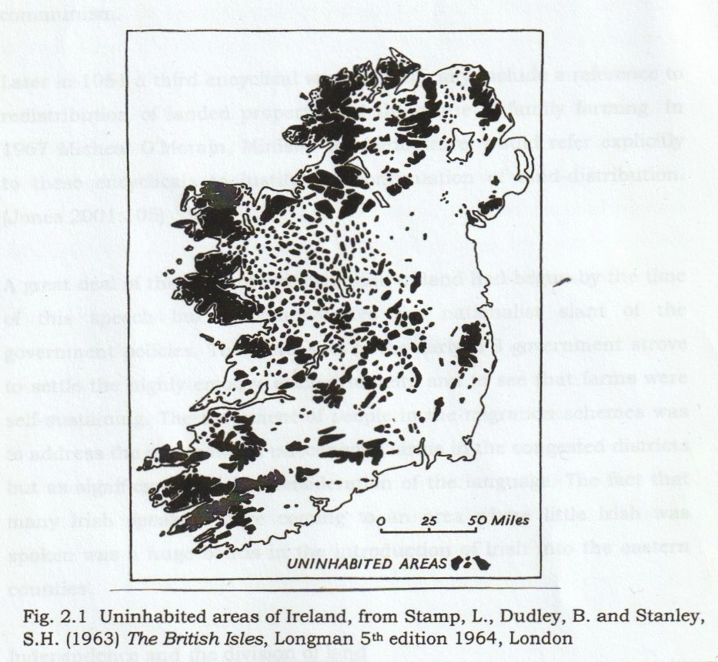
Primarily the main occupation at the time was farming and this required sufficient land to meet the needs of the family and the market. Non-farming families produced their own food and even plots under an acre could mean the difference between self-sufficiency and starvation. As Slater and McDonough (1994) have shown, historically, rent in Ireland was paid on a cash basis. With a need to pay cash rent, families required enough produce to sell to pay the rent in cash with enough left over to live on. For this arrangement to work it was necessary to have enough land to create surplus produce for market.

Much of Ireland is unsuitable for crops because of the climate, the topography, the basic fertility of the soil and the physical condition of the soil. Large portions of agricultural land were devoted to raising stock and as a result supported fewer inhabitants than arable land. Some land, regarded as being available for distribution, was leased as conacre (that is, on an 11-month lease) as grazing land and outside the scope of the ILC. Ultimately for a county whose chosen agricultural preference was for grazing, there were far too many people.

Other significant reasons that drove the craving for land were more emotive needs. As a status symbol land, was the ultimate possession. To occupy land as owner or tenant placed one in a class above the humble rural labourer. Craving came under a spiritual guise as well, ‘the land belonged to the Irish people and it had been taken away from them’. This refers to the Cromwellian period which advocated confiscation but which has historically been shown to have been greatly exaggerated and in many cases short term. (Duffy, 2003)

The IFS set up in 1923 began to tackle the land question as its priority. It may seem with hindsight that the partition of Ireland would have been the overriding concern but in fact, this was not the case. As Patrick Hogan, later Minister for Agriculture and Land Commission in the IFS, stated “The relief of congestion is a difficulty that stands out by itself. On the western seaboard especially, there are very large numbers of miserably poor tenants living on wretched holdings…” (Hooker 1938:163)

The Hogan Act of 1923 addressed the conflict between the competition for land in the congested districts by migrants and the local landless. A solution to this conflict was the migration of the larger and better-educated tenants. It was hoped that the land they gave up would not cost a great deal to improve and they could adjust to a new holding easily.

Land under the Land Commission for both the colonial period and the period of the IFS under the Irish Land Commission was eligible to certain classes. (Section 31 of the Land Act, 1923) Those classes or categories that were eligible for parcels of land, and may have already had land to begin with, were occupiers of uneconomic holdings on estates or in the vicinity of the estate. The landless could at the discretion of the Land Commission have some claim to a farm. The categories of landless were; sons of tenants, agricultural labourers, evicted tenants and WWI ex-servicemen. Individuals outside of these categories, again at the digression of the Land Commission, could be sold parcels of land if they were deemed as deserving as those above. It was stipulated that land for this group must not be made available if it was needed for redistribution. In reality, all land acquired was needed for redistribution. One can see how with the flexibility built into the categories; it might be open to abuse. Hogan saw the problem of the landless as more serious than the migrants and this issue would soon become a contentious political issue.

Sammon (1997) in his memoir of the ILC assures the reader that individuals who sought land through a political representative were largely unsuccessful. However, one has only to look at those FF supporters who ultimately did receive land from the 1930s onwards that direct intervention was unnecessary if policy and loyalty were a given. Two FF Ministers for Agriculture were from Mayo, Joseph Blowick 1948-51 and 1954-7 and Michael O’Morain 1959-68. This is reflected in the relocation of considerable numbers of their landless constituents to the fertile lands of Meath and Kildare thus moving not just the native Irish speakers to the east but the support for the FF party. (Nolan 1988:311)

The category concerning agricultural labourers was included due to the fact that in some cases jobs were lost if the estates were redistributed. These men were compensated in the form of loans for purchase of lands. In addition, built into the Land Act of 1936 was a compulsory acquisition order specifically regarding land for labourers.

The next category of evicted tenants was highly emotional and applied to tenants who had lost holdings during the Land War of the 1880s. These individuals and families represented heroes and martyrs of a struggle, the fruits of which those in the early years of the state saw themselves as beneficiaries. Initially, in the Land Act of 1903, those who had been evicted up to 25 years previously were eligible. The arrangements for this group would become in the future a decidedly sensitive political issue and changes were to come about as to the eligibility and benefits. A Land Act of 1907 was drawn up to address the evicted tenants and a compulsory purchase order was drawn up to cater for them. It would bring about a fundamental change to the other categories and take precedence in many cases over the previous allotment or long term sitting tenant. 3,587 evicted tenants had been installed as tenant purchasers by 1909. In 1914 however there were complaints in parliament that “hundreds of evicted tenants remained without relief…. and two courses were open, emigration or violent agitation” (Hooker 1938:154)

As late as 1923 the first land act of IFS included evicted tenants and incredibly this allowed for tenants evicted up to forty-five years previously. In some cases, money was demanded in lieu of land but this was not entertained. By 1938, which ended the period that allowed evicted tenants to apply, 191 had been accommodated by the state, bringing the total to 4,000. Some were accommodated on their previous holdings even if these holdings had been previously allocated and others were allotted holdings on new nearby placements. Local people did not always welcome these arrangements and felt that evicted tenants should not automatically be given their original holdings back. There were margins for flexibility however if the ILC was convinced that the current tenant purchaser was doing a good job there was a strong possibility that he would be allowed to stay and the evicted tenant given another holding.

The ex-servicemen category, Naval, Army and Air Force and was a policy that covered agricultural holdings or cottages with garden plots for rent. Ex-servicemen could acquire the land by the same arrangements as the tenant purchaser over a three-year period. Like the landless group this was a flexible decision. Individuals had to be fit and suitable, and they could be given holdings or cottages in an area of their choice. These, in the case of cottages, were decided by the government and were placed in urban locations grouped in garden settlements not in isolated rural settings. Hooker describes a very complex operating system from 1903 until the end of the application period in 1929 which involved house types, rent arrangements and tenant purchase. Originally “a superior house to the agricultural labourer’s” was built not exceeding £500 for house and plot. Later at the completion of the scheme in 1935, when the Irish government sought to fulfil its obligations, smaller cheaper cottages were built. The last report in 1934 of the Soldiers and Sailors Land Trust which had been set up to oversee the scheme, a total of 2,719 cottages had been built in what was by then the IFS.

As time went on, it was the landless that were becoming a larger political issue. In 1933 a Land Act under Fianna Fail influence allowed the ILC greater powers than it had previously enjoyed under the IFS which were considerable. The commission now had greater compulsory purchase capability; it could requisition a demesne, a home farm, a building site, or the holding of a tenant purchaser. This was to apply even if a suitable site existed in the vicinity. However, if the occupier had no other land over the value of £2000 and was farming efficiently one of equal value may be provided. In some cases compulsory purchase might go ahead, regardless of proper farming, for pleasure grounds, for school gardens but not, surprisingly, to the landless. The trouble was many saw the preference for the landless as unacceptable particularly as the more suitable ‘herd’ was often turned away. This, while politically good for the party, was economically foolish as in the end these landless men were being given uneconomic holdings. It was felt possible that an increase in congestion could occur. (Hooker 1938:165-6)

In the lead up to the bill of 1933 Hogan spoke in the Dail of the need to consider the landless. Giving them uneconomic holdings was not enough if they were to live. Breaking up the big farms took away their employment and uneconomic holdings were not a replacement. An additional land bill of 1936 went further giving the landless an even greater advantage. Land could be compulsory purchased after seven years in the ownership of an earlier tenant purchaser undermining the long sought security of tenure. Mr Dillon a member of the Fine Gael opposition was outraged and accused FF of pandering to the by now voting labourers. He accused the government of giving out land “if their influence is flagging in a particular part of the constituency.” Without denying the accusation the FF majority passed the bill. (Hooker 1938:167) At the heart of the matter as Bew et al show FF had a problem, it could not adopt policies that appealed to the poorest of the farming communities in the west- land distribution- without alienating the strong farmers of the south and east. (1989:43)

When the 1938 Annual Report of the ILC was published the landless out numbered the migrant allottees by 15.2%. It was the landless too that had a greater percentage share of the available land, 27% compared to the migrants at this time of 24%. By 1939 the landless had dropped by half and the land proportionately. As the numbers of migrants increased steadily the landless dropped rapidly to insignificant numbers. (Annual Irish Land Commission Report 1938-1939. NAI) In 1959 for example when the migrants peaked at 21,265 the landless numbered only four. While the landless were considered a contentious political issue in the early 1930s it is evident from the statistics that by the early 40s this had been resolved.

From the early 1940s a split occurred within FF as to how beneficial land-distribution actually was. The first more traditional group saw it as vital and had accomplished three objectives. First it kept as many people on the land in economic security as possible. Secondly it maintained the traditional rural culture based on the small family farm. Finally, it sustained economic self-sufficiency. (Jones, 2001) These were the guiding principals that shaped FF land-distribution policy and reflected De Valera’s vision.

The second group was sceptical and saw land-distribution as harmful to agricultural economy. Their priority was to improve the production and viability of Irish agriculture based on modern farm practice and technology. They saw the breakup of the commercial grazing farms as an anathema to those aims. They also felt that the standard of living for the allottees (or congests as they were often referred to) was not significantly improved and only perpetrated small-scale traditional farming. (Jones 2001:87)

Despite internal conflict FF went ahead with the migration and redistribution schemes, walking a fine line between political clientelism and economic dependency to the United Kingdom. To scale back the land-distribution would risk electoral support, to which it was directly linked. Minister for Lands Micheal O’Morain T.D. in a speech to the Agriculture Science Association in 1962 was still championing land resettlement. “With the extent of rural congestion …it goes without saying…every acre of land which becomes available for acquisition must be acquired to cope with it.” (Annual Irish Land Commission Report 1962:3. NAI)

Chapter Three: Case Study of Kilmacredock
As was suggested in the introduction, the social impact of the policies of the Irish State and the redistribution of lands by the Irish Land Commission will be considered in a case study of the townland of Kilmacredock.
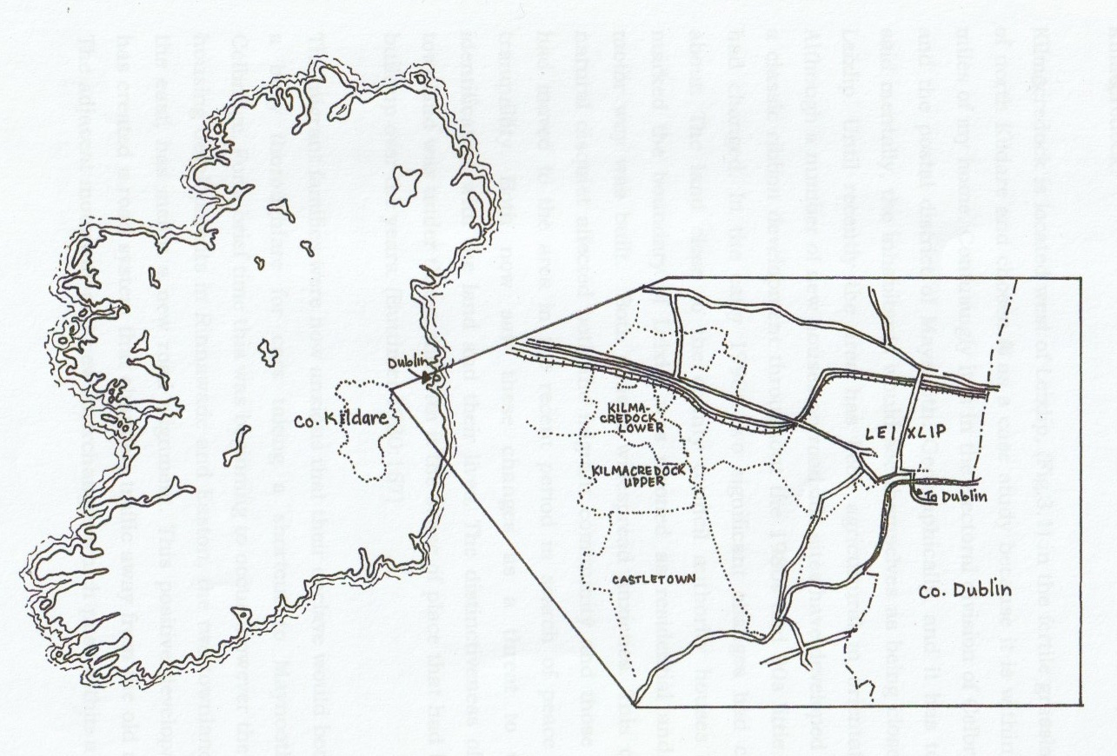
Fig. 3.1 Kilmacredock townland. OSI (revised 1939)

Kilmacredock is located west of Leixlip, (Fig.3.1) in the fertile grasslands of north Kildare and chosen as a case study because it is within 1.5 miles of my home. Confusingly it is in the electoral division of Celbridge and the postal district of Maynooth. Geographically, and it has to be said emotionally, the inhabitants would see themselves as being closer to Leixlip. Until recently the area has been agricultural in orientation. Although a number of new houses on roadside sites have developed into a classic ribbon development throughout the 1980s and 90s little else had changed. In the early 1990s two significant changes had come about. The land close to the county council authority houses that marked the boundary of Leixlip was rezoned as residential and the motor way was built. Both caused widespread anxieties. This quite natural disquiet affected both the migrant community and those who had moved to the area in the recent period in search of peace and tranquility. Both now saw these changes as a threat to their identification with the land and their lives. The distinctiveness of the townland was under threat and with it the sense of place that had been built up over the years. (Buttimer 1980:167)

In the Ireland-wide Valuation carried out by Richard Griffith in the mid-nineteenth century, it can be seen that the townlands of Kilmacredock are divided into Upper and Lower. Griffith’s Valuation of 1851 shows that there were eight houses to be found in the townland. The valuation identified, including the eight mentioned, altogether sixteen separate units. Fourteen units consisted of houses, gardens and were owned by four individuals. Two acres which included the railway and canal bank were owned by the Midland and Great Western Railway. Adding up the acres only two are significant, Wm. Bellingham, owning 288 and Thomas Conolly (1823-76) owning 183 acres. The Duke of Leinster and Robert Heir owned less than one acre between them.
The Cancellation Books, the development of the survey, reveal that Sir Gerald Deasy’s son William purchased from Thomas Conolly (1871-1900) the lands of Kilmacredock in the Castletown estate between 1901-6. Soon after, James Lennon was sent from Celbridge Abbey, where his father was the steward, to look after Kilmacredock as the ‘herd’. James, who described himself as a shepherd, his wife Norah and their four children appear in the Census of 1911. They lived in a 2nd class house and had fourteen out-offices and farm buildings, a substantial number. Living with them was a farm labourer to assist James. The other family living in the townland was Francis Hughes, his wife Sarah and their three children. He described himself as a ploughman and was possibly also working for James Lennon.
By the census of 1911 only two householders in Upper and Lower Kilmacredock are recorded. In as much as one can understand the complicated notation in the cancellation books in the Land Registry between 1910 and 1935 the fields and houses of the townland were purchased by the Land Commission.

In 1932 when Fianna Fáil came to power in coalition with Labour and the Farmers Party, they were determined in their desire to create a society with a predominantly rural focus. For the party, land division was a key priority, which was directly linked to their political survival. In line with their stated policy, they were resolute in the effort to speed up the land redistribution.
Fianna Fáil, recognised that a huge political credibility would be achieved if they were to alleviate the congestion on farms in the western counties. Within the context of the wider land reform policies, they perceived that migration was the most effective method of approach. Coupled with this was the implementation of a suggestion made some four years previously in the Gaeltacht Commission Report of 1927 which was to spread the Irish language through migration of Irish speakers. Eventually FF would set up a total of 5 colonies known as Gaeltacht colonies. This was ground breaking social engineering and against some opposition, fertile grasslands of the midlands were acquired and the land divided into small farms in Meath.
Other Gaeltacht colonies would rapidly follow in succession, and over the next five years a further four colonies were created. Altogether this involved 118 Irish speaking families, in 5 townlands, all within a fifteen mile radius of each other. But the experiment in this format would be effectively finished even before difficulties arose with the outbreak of war in Europe in 1939. It was becoming clear to many that colony migration was turning out to be prohibitively expensive. The final colony of Allenstown, was agreed upon in 1939 and put in place in 1940. However, in c.1943 indications in the ILC reports were that from 1939 the policy of migrating Irish-speaking colonies of people would be scaled down. The colonies would be replaced by the group scheme ‘as ancillary to ordinary individual migration and less expensive, troublesome and unwieldy than the large colony migrations.’ The group migrations were destined not only to Meath but also to Westmeath, Kildare and Dublin. The 1943 ILC report puts the group migration at 168 totaling 1,008 individuals.
The five families who originally came to Kilmacredock between 1958 and 1959 were the Keirs from Ballyglass, County Roscommon, the O’Flaherty’s, Faherty’s and Connelly’s from Rossaveel (Fig. 3.2) and Hopkins from Barna. The Galway families were fluent Irish speakers.

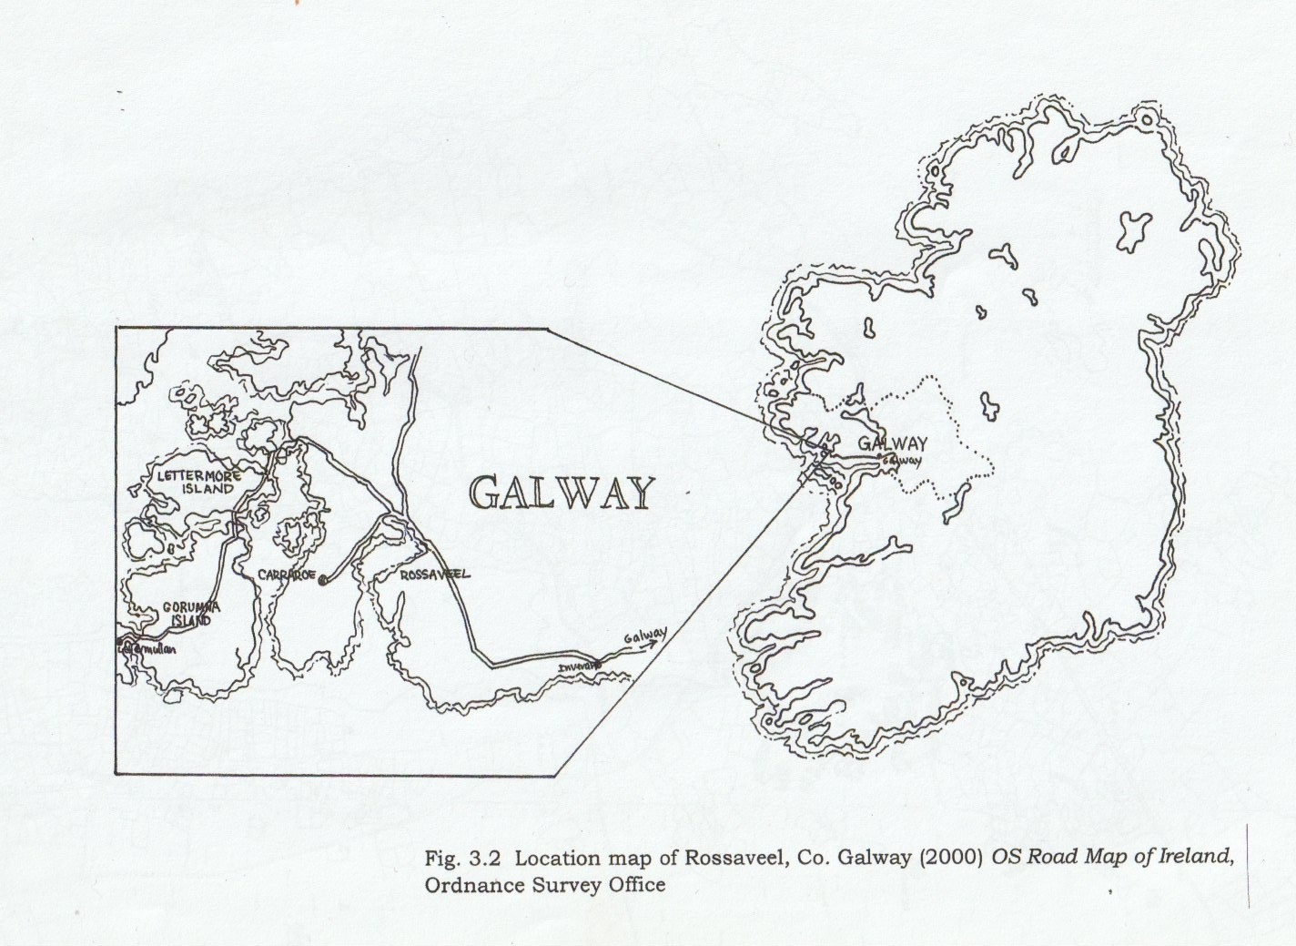

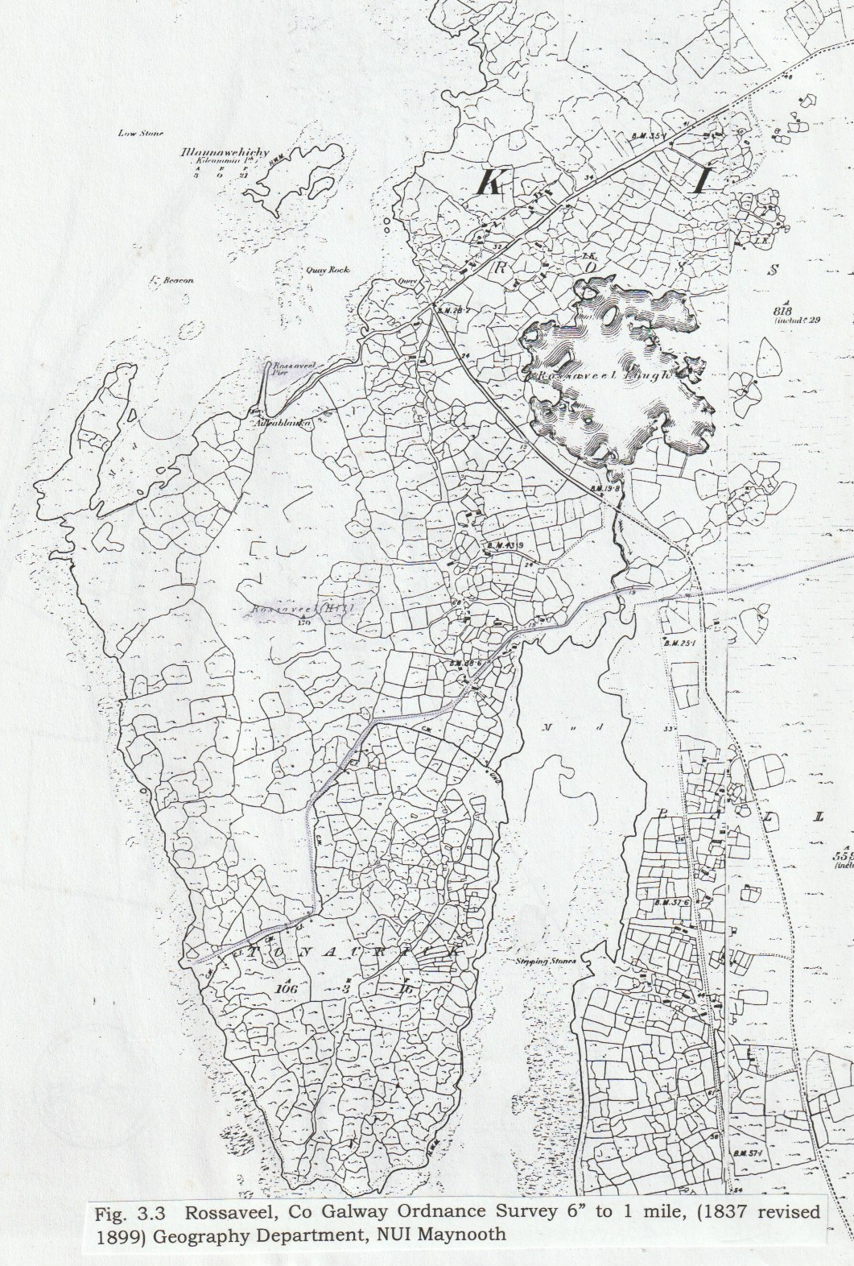
The map Fig. 3.3 shows the townlands of Rossaveel where one can see the striking difference of the field patterns in Co. Galway compared to those of those of Kildare. In the west the smallest farms were of one to ten acres while in Kildare the empty landscapes might have farms of fifty to 100 acres. (Duffy 1998:37) Griffith’s Valuation of Rossaveel shows 23 tenants living on 773 acres. Rossaveel, within the parish of Kilcummin, is not listed separately in the Census of Population returns it is within the Kilcummin DED. This shows a population of 1,410 in 1951 and increase of .3% on 1946. In 1956 this number has decreased to 1,351 and by 1961, following the migration to Kilmacredock, it has fallen again to 1,161. While some of the decrease is due to migration, as we know to Kildare the remainder may be a result of other factors perhaps even migration to other parts of Ireland. In the 2002 census the population had not reached the 1951 figure and was recorded as 1,298.

The final two maps show the townland of Kilmacredock: the first prior to the redistribution of the lands and the second shows surprisingly few changes following their arrival. (Fig. 3.4, 3.5)
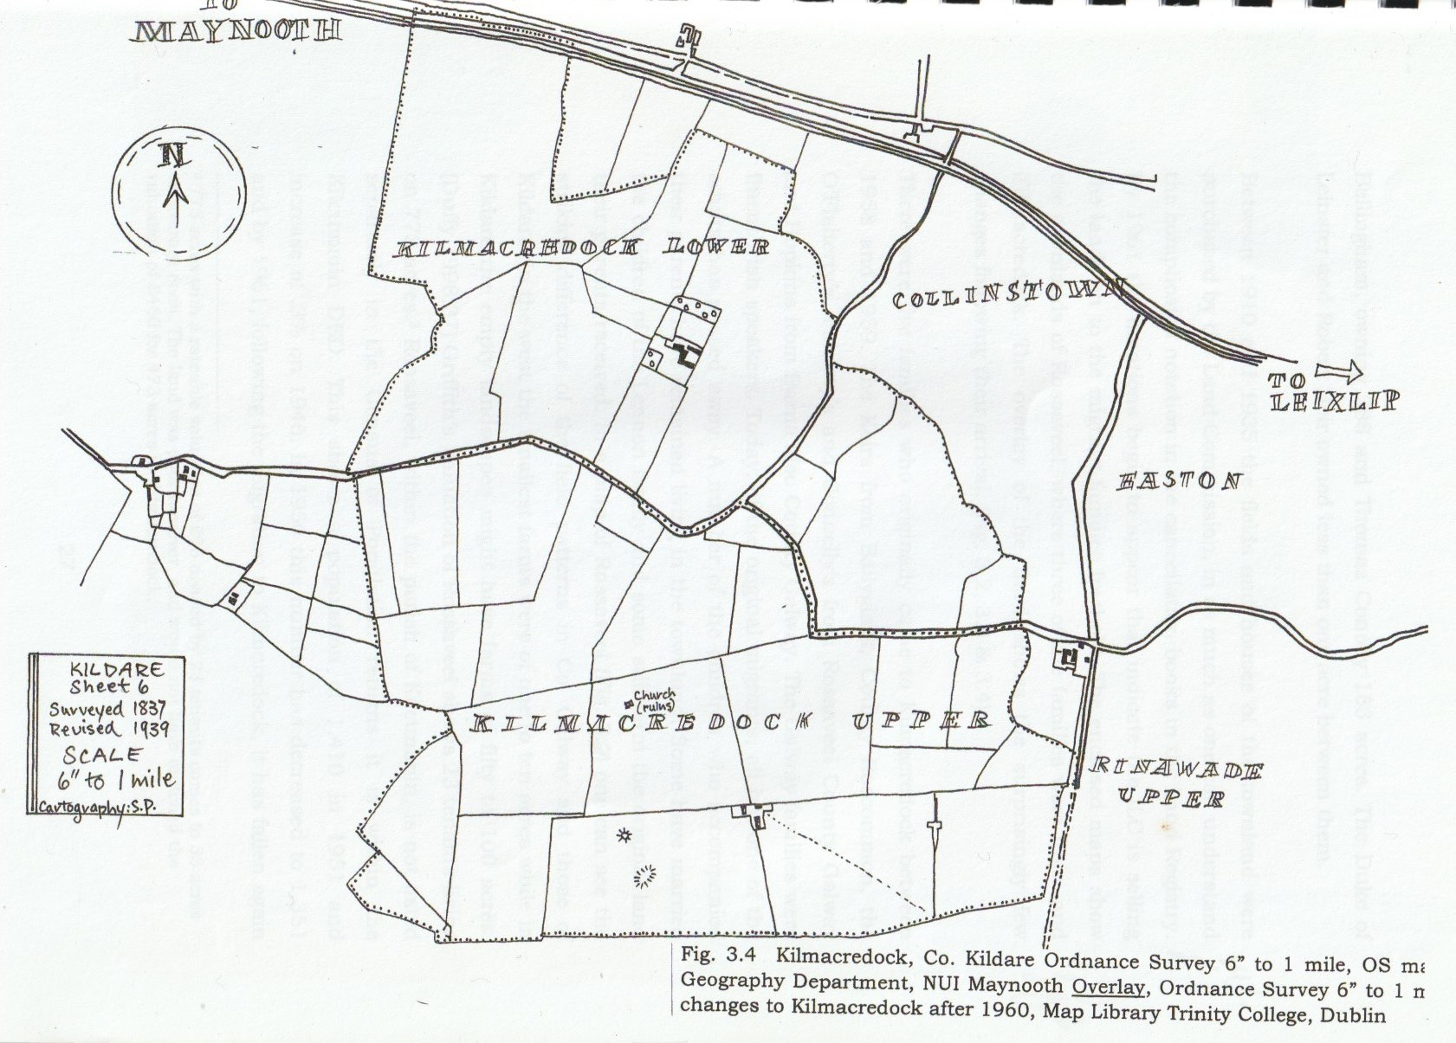
Fig. 3.4 Kilmacredock OSI (Revised 1939) Cartography S. Pegley
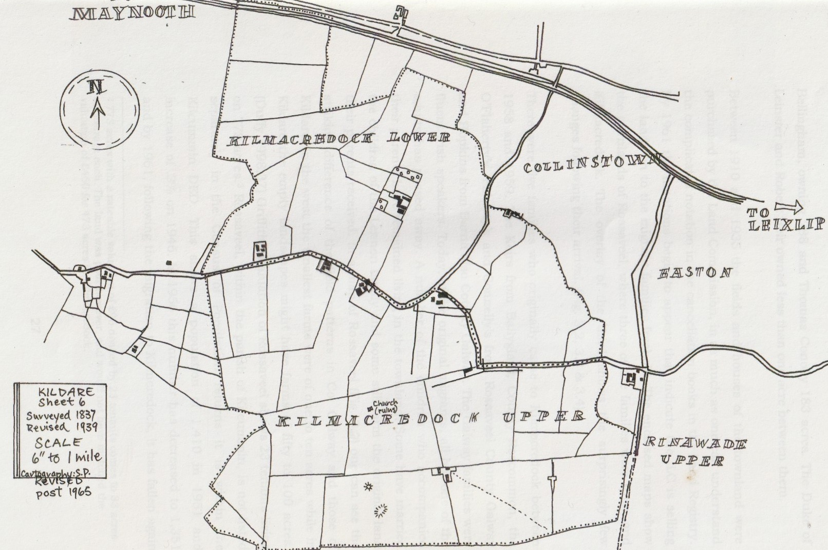
Fig. 3.5 Kilmacredock OSI (Revised 1965) Cartography S. Pegley

In 2004, of the original migrants, all but one of the adults has passed away. A number of the children who accompanied their parents have remained living in the townland. Some have married the children of the Lennon family and some still farm the original land their parents received.
A number of individuals who were part of the migration group have been interviewed for this case study. One was a child when the family arrived and was thrilled to be so close to Dublin and the bright lights. May Keir’s parents had made a decision to become migrants because of the health of their mother. It was believed that the dryer air of Kildare would be beneficial for the rheumatism she suffered from and this proved to be true. Others stated that with improved land and more acres they would be better off. While this certainly was true in theory, the reality was that into the 1960s the land was of diminishing viability.
By 1961 notations in the Cancellation Books begin to appear indicating that the ILC is selling the lands on to the migrant family’s freehold.

Tovey and Share have examined the notion of community and in this study the concept has been applied to Kilmacredock. ‘Community as place’ could be one way to describe the end result of the ILC policy on this townland. Overlapping with ‘community as relationships’ it could describe the consequence of grouping the new migrant houses adjacent to one another. An ‘outsider’ however, cannot judge the extent of relationships that may have developed particularly after so many years have passed. It appears that everyone helped each other and that ‘cooring’ was an important feature of the relationships the families had with each other. (Plate 3.1) Formal and multidimensional relationships are dependent on people having considerable knowledge of each other’s lives. Coupled with this is also the assumption that even if not everything is known, attitudes of beliefs and experiences are going to be similar to ones own.
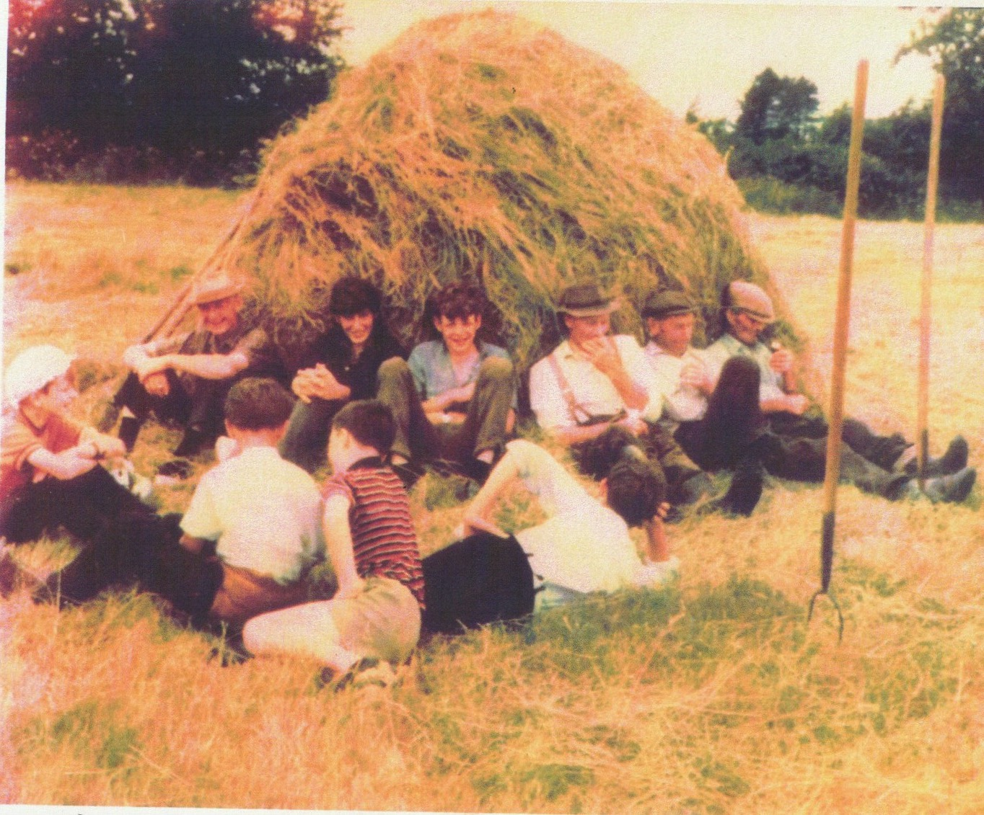
Figure 3.1 Saving the Hay 1960s. Collection of Eileen Lennon Front from left: Paraic Lennon, Michael Lennon, Pat Kennedy, Against the hay: Eddie Keir, Donal Lennon, Jerry Keir, Miley Lennon, Paudin Faherty, Matty O’Faherty

To assign the migrants of Kilmacredock particular identities and social relationships would be tempting but would be to reduce them to stereotypes. One can however suggest that they probably had feelings of shared identity and this would have created a common bond. Their occupational, religious beliefs, social class, language (four of the five families had Irish) and migrant status would have given them at least a public community relationship. (T&S 2000:336)

Spatial pattern of settlement for the newly arrived residents would have established an artificial community nearly overnight. As is demonstrated by the map of the townland, (Fig. 3.1) most of the houses are clustered toward the centre along the road, which divides Upper and Lower Kilmacredock. The exception is the new home of the Lennon family (similar to Plate 3.2.) that was built on the townland boundary. On the Lennon’s former site (Plate 3.3) a new house was built for the Keirs, with the remaining four houses along the ‘main’ road. The four Irish speaking families were therefore closer together but still it is a small townland and no one family was very far away. The formation of a new identity would have been of paramount, if unconscious, concern to the new arrivals.
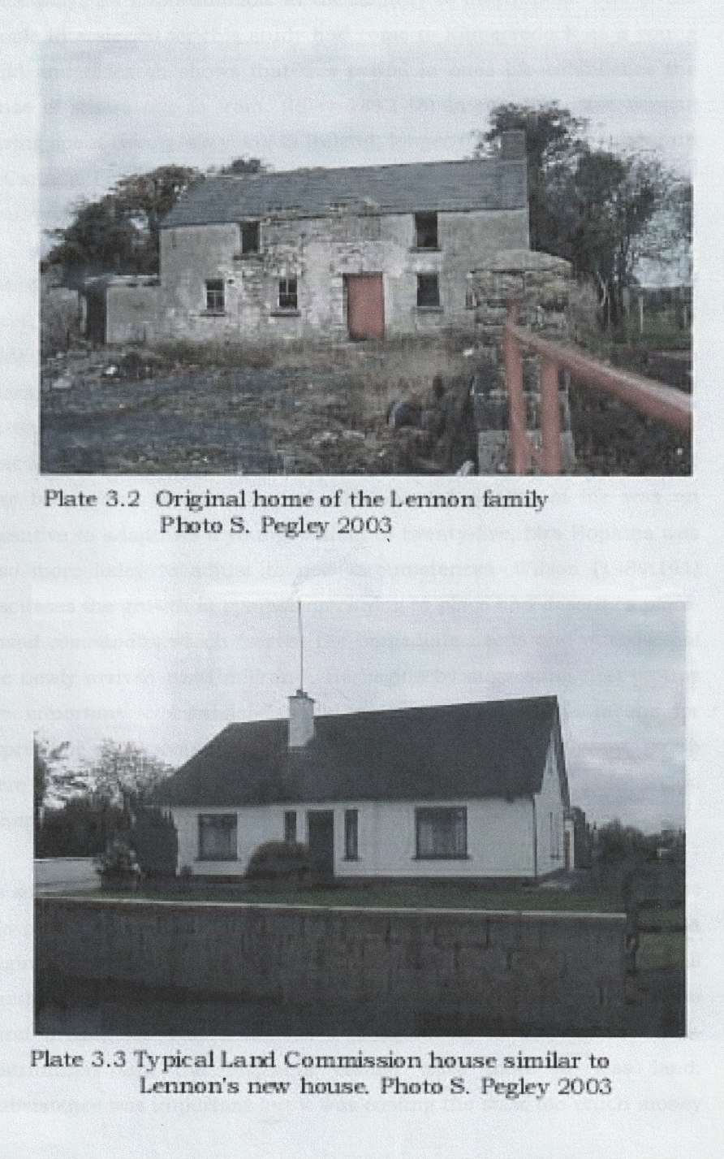
The surrounding townlands, which were also farmed, were sparsely populated. It was not until one came closer to Leixlip that there were a relatively larger number of people. While isolated is perhaps too strong a word, one can see how they would have naturally looked to each other for support. Duffy (1998:26) suggests that the shaping of the landscape is of central concern and is a legacy of past generations. But these past generations were unknown to the new arrivals and their farming practices were unfamiliar. The families would have undergone considerable upheaval, much like emigrants to another country.

Place plays an important role in the identity of individuals. One of the people interviewed for this study had come to Kilmacredock as a young child and research shows that this period in one’s life establishes the sense of where one is from. (Riley 1992:18) In my own case despite having spent twenty-six years in Ireland, longer than I spent growing up in Canada, I continue to see myself as being from Weston, Ontario, now a suburb of Toronto.

The remaining adult migrant Nora Hopkins expressed how she felt bereft of the presence of the sea and the mountains of Barna. Here in Kildare, she felt closed in by the fields and hedges, even the Dublin Mountains were a long way away. The physicality of place was part of Nora’s identity. It was only time and the comfort of other Irish speakers that allowed her to settle in. Pragmatically she knew that here the land was better and the prospect of an improved quality of life was an incentive to adapt. As a young woman of twenty-five, Mrs Hopkins was also more likley to adjust to new circumstances. Wilson (1980:141) discusses the growth in symbolic meaning to place and describes place-based community, which “serves the immediate needs and purposes of the newly arrived rural migrant”. He begins by suggesting that groups are important to establish spatial patterns and are the means for expressing environmental experiences. (Ibid:143) The migrant group were important to each other to generate the meaning of place in an otherwise meaningless place.

As society modernises, in order to remain viable, farmers must increase the area of land they farm. Already in the 1940s this problem was beginning to manifest itself. There was some concern that the small family farms were not going to fulfil the ideals of De Valera's Arcadian rural dream. De Valera himself was agonising as to whether land–distribution and the migrants should have more or less land. Subsistence was important but it was costing the state too much money as time went on to continue to acquire lands and to carry out improvements. Despite this concern there was an increase in land offered. In the 1930s holdings were averaging twenty-two acres and by the late 1950s and 60s, forty to forty-five acres was the norm. (Nolan1988:311) However by the 1960s the numbers of migrants had fallen to a trickle; the days of large landed estates being redistributed were gone. Increasingly, off farm jobs were necessary to continue to live at a subsistence level. The economic conditions in the 1960s it has to be said were desperate for the small farmers. In Kilmacredock one of the farms was sold and has become part of a larger stud farming enterprise. The remainder, while carrying on, have sold sites to ‘outsiders’, their own family members and have off farm jobs.

The migrant families were now anxious that their enclave would become a busy thoroughfare for cars taking a shortcut to Maynooth or Celbridge. For a brief time this was beginning to occur however, the new housing developments in Rinnawade and Easton, the two townlands to the east, has meant a new road alignment. This positive development has created a road system that channels traffic away from the old road. The adjacent motorway and new interchanges which pass within a field of many and a garden for others has proved both good and bad. It has taken away much of the anticipated traffic but the hum of traffic is audible and the light pollution is intrusive. For all this the area continues to have a much more rural feel than would be suggested by its situation.

The legacy for the migrant families in the counties of Meath and Kildare is quite positive in many respects. They live in what Lorne Russwurm, and urban geographer, has described as the urban shadow, neither rural nor urban. This creates a dichotomy that is becoming a new area of geographical and sociological study. On the one hand a way of life and sense of place is undergoing varying degrees of change which can bring feelings of uncertainty. For the migrants of forty years ago a second upheaval might prove to be a more upsetting event than the first. Then again anyone owning land close to an expanding city is sitting on a huge financial gain. Farms of thirty acres and land of smaller amounts are changing hands in the Ratoath area of Co. Meath in the one million Euro range. (Smith 2004) Kilmacredock has yet to experience change on this scale but driving through, one can see that a ribbon development is emerging. As yet this area is cut off somewhat from the hustle and bustle of other off-road expansion. Perhaps it is because I remember it as just the ‘mucky lane’ of 30 years ago or perhaps because I too want to hold something of De Valera's Arcadian dream somewhere not too far out of reach.
Remembrance of a particular form is but regret
for a particular moment; and houses,
roads, avenues are as fugitive, alas as the years.
Remembrance of things Past, Marcel Proust 1934
Conclusion
The Land commission accomplished in the 108 years of its official existence a reordering of land ownership equal only to that of the Cromwellian Settlement. That this was a willing transfer of ownership puts it in quite a different category. In the 1970s the Irish Land Commission was pronounced closed and the final report published in 1978. Having declared the concept dead however, the body continues to operate behind closed doors. Not even the Freedom of Information Act will open them. The overwhelming accomplishments are indisputable never the less and the statistics are worth quoting. From the start of the colonial land-distribution until 1923 when the final handover occurred, 750,000 acres had been redistributed. By 1978 when the ILC was considered wound up the Irish State had allotted 2,187,000 acres and with the colonial figures make close to 3 million acres. (Sammon 1997:258)

Elizabeth Hooker asked in 1938 “What did land purchase do for the small farm occupiers?” She answered her question by stating that they had gained a consciousness of ownership and eliminated the fear that it might all be taken from them. She went on to say that improved land in congested districts became available and in addition, improved land for migrants was offered. (Hooker 1938:204) But as has been shown, that security could be undermined by the State at any time if it suited them politically. During the period this study is mainly concerned with, 1923 to the 1960s, the Fianna Fail Party was endeavouring to establish, not alone their place in the political scrum but the establishment of a new definition for Ireland. They needed to find an identity, one that was not the colonial way, and those years were ones of trial and error. As I have shown their manipulation of the constituents for political gain was unacceptable a situation that, in shades of grey, continues today.

The Irish Land Commission, while it tried to operate at arms length from the personalities of individual politicians, were working within an ethos of ‘land for the boys’. Sensitive to the exposure of personal details to researchers the records of the ILC remain closed, denying access to a fundamentally important period of the development of the Irish State. Annual Reports continued to be published into the 80s with a number of migrants allotted holdings. I have shown superficially how the migrants of Kilmacredock were affected by their part in this great social change. By applying this to the entire country and as the statistics have shown, it is so far-reaching, that I would suggest a social revolution has taken place through the policies of the then Fianna Fail Government and Eamon De Valera.

Bibliography

NOTE: 2022
See ‘The development and consolidation of Rath Cairn, Co Meath: The first Gaeltacht Colony’ an unpublished MLitt thesis by Suzanne M. Pegley, 2007 NUI Maynooth.
Also The Land Commission and the Making of Rath Cairn the first Gaeltacht Colony by Suzanne Pegley (Dublin, 2011).

Allen, K. (1997) Fianna Fail and Irish Labour 1926 to the Present, Pluto Press, London

Bew, P., Hazelkorn, E., Patterson, H. (1989) The Dynamics of Irish Politics, Lawrence and Wishart, London

Buttimer, A. (1980) “Home, Reach, and the Sense of Place” in, Buttimer, A. & Seaman, D. The Human Experience of Space and Place, Croom Helm, London

Comerford, R.V. (2003) Inventing Ireland, Arnold, London

Cronin M. (2000) “Politicising the land issue” in Kay Mackeogh (ed) Land Politics and Society in Ireland 1840-1922 OSCIL Dublin City University

Dooley, T. (2001) The Decline of the Big House in Ireland, Wolfhound, Dublin

Duffy, P.J. (1998) “Locality and changing landscape” in, Gillespie, R. & Hill, M. (eds.) Doing Irish Local History, The Institute of Irish Studies. The Queen University Belfast

Freeman’s Journal (7-9 August 1850) (2000) facsimile in Kay Mackeogh (ed) Land Politics and Society in Ireland 1840-1922 OSCIL Dublin City University

Hooker E. (1938) Readjustments of Agricultural Tenure In Ireland University of North Carolina Press

Jones, D.S. (2001) “Divisions Within the Irish Government over Land-Distribution Policy 1940-70”, Eire-Ireland XXXVI:III&IV pp 83-110

Kolbert C.K. and O’Brien, T. (1975) Land Reform in Ireland, University of Cambridge Department of Land Economy, Occasional Paper Number 3

McCourt, D. (1981) “The Decline of Rundale” in Peter Roebuck (ed.) Plantation to Partition, Blackstaff Press, Belfast

Moynihan, M. (1980) Speeches and Statements by Eamon De Valera 1917-73, Gill and MacMillan, Dublin

Nolan, W. (1988) “New Farms and Fields: Migration Policies of State Land Agencies” in, Smith, W.J. & Whelan, K. (eds.) Common Ground, Cork University Press

O’Tuathaigh, G. (1972) Ireland before the Famine, Gill and MacMillan, Dublin

Proust, M. (1934) Remembrance of Things Past (CKS Moncrief, Trans.) Random House, New York

Riley, R.B. (1992) “Attachment to the Ordinary Landscape” in (eds.) Altman, I. & Low, S.M. Place Attachment, Plenum Press, London

Ruane, J. (1992) “Colonialism and the Interpretation of Irish Historical Development” in Silverman, M. & Gulliver, P.H. (eds.) Approaching the Past: Historical Anthropology through Irish, Columbia O.P., New York

Russwurm, Lorne H. (1977) The Surroundings of our Cities, Problems and Planning Implications of urban Fringe Landscapes, Community Planning Press, Ottawa

Sammon, P.J. (1997) In the Land Commission: A Memoir 1933-1978, Blackhall Publishing, Dublin

Slater E. and McDonough, T. (1994) “Bulwark of Landlordism and Capitalism: The Dynamics of Feudalism in Nineteenth Century Ireland” in Research in Political Economy 14: 63-118

Smith, S. (2004) A Changing Sense of Place Discourses from the Urban Shadow, unpublished BA dissertation

Tovey, H. and Share, P. (2000) A Sociology of Ireland, Gill and MacMillan, Dublin

Wilson, R.M. (1980) “Social Space and Symbolic Interaction” in Buttimer, A. & Seaman, D. The Human Experience of Space and Place, Croom Helm, London

Bibliography

Primary Sources

‘Cancellation Books’ 1859-1965, Land Registry, Barony of North Salt, County Kildare, townlands of Upper and Lower Kilmacredock

Census Population of Ireland 1911, original returns,
County Kildare, Leixlip DED, Kilmacredock, National Archives

Mr Keanan’s Books, National Library
Survey of Land Commission records accumulated from 1881 to 1909, relating to 9,343 estates, by folio number

Secondary Sources
Annual Report of the Irish Land Commission: presented to the house of the Oireachtas by the Minister for Agriculture, National Library, Shelf reference L1 according to years
LI/28 1953/4
L1/33 1957/58
L1/34 1959/60
L1/35 1960/61
L1/54 1980
L1/55 1981
L1/56 1982

Census Population of Ireland 1951, 1961, 1979, 2002
The Stationary Office

Griffith’s Rateable Valuation of Ireland (1851) Co. Kildare, Barony of North Salt, Parish of Leixlip, Kilmacredock

Hannan, D.F. and Commins P. (1990) The Significance of Small-Scale Landholders in Ireland’s Socio-economic Transformation, Proceedings of the British Academy, 1992, 79, 79-104

Lennon, M. (2000) Leixlip 2000 Celebrating 100 years People, Place, Memory, Leixlip Town Commissioners, Leixlip

Proudfoot, L.J. (1985) “Spacial Transformation and Social Agency: Property, Society and Improvement, c. 1700 to c. 1900” in Graham B.J. and Proudfoot, L.J. (eds.) An Historical Geography of Ireland

Web Site
www.oireachtas/debates.gov.ie

Maps
Fig. 1.1 Map of Congested Districts Congested Districts of Ireland, from Hooker, E. (1938) Readjustments of Agricultural Tenure In Ireland University of North Carolina Press
Fig 2.1 Uninhabited areas of Ireland, from Stamp, L., Dudley, B. and Stanley, S.H. (1963) The British Isles, Longman 5th edition 1964, London
Fig. 3.1 Location map of Kilmacredock, Co. Kildare Ordnance Survey maps, (1837 revised 1939) Geography Department, NUI Maynooth
Fig. 3.2 Location map of Rossaveel, Co. Galway (2000) OS Road Map of Ireland, Ordnance Survey Office
Fig. 3.3 Rossaveel, Co Galway Ordnance Survey 6” to 1 mile, (1837 revised 1899) Geography Department, NUI Maynooth
Fig. 3.4 Kilmacredock, Co. Kildare Ordnance Survey 6” to 1 mile, OS maps, Geography Department, NUI Maynooth
Overlay, Ordnance Survey 6” to 1 mile, changes to Kilmacredock after 1960, Map Library Trinity College, Dublin

Photographs
Plate 1.1 Land Commission Payment Sheet, Oldtown, Celbridge, Co Kildare
Plate1.2 A typical house in the Congested Districts Monivea, Co. Galway. Photo by Robert J. Welsh, c1906-1914, National Photographic Archive, www.ipac.ie
Plate 1.3 An improved holding in the congested district of Monivea, Co Galway. Photo by Robert J. Welsh, c1906-1914 National Photographic Archive, www.ipac.ie
Plate 2.1 Eamon De Valera 1943, from Fitzgibbon, C. and Morrison, G. (1973) Life and Times of Eamon De Valera, MacMillan, New York
Plate 3.1 Saving the hay, Kilmacredock late 1960s generously lent by Eileen
Lennon, Kilmacredock
Plate 3.2 The original home of the Lennon family taken by the author 2003
Plate 3.3 Typical Land Commission house similar to Lennons', Kilmacredock, taken by the author 2003

Appendix 1

Nineteenth Century Land Reform

Summary of the Occasional Paper by C.K. Kolbert and T. O’Brien (1975) Land Reform in Ireland, University of Cambridge Department of Land Economy

The radical overhaul of the system of land holding in Ireland began as I indicated above with the land reform bills put forward in the second half of the nineteenth century. A very useful book by Kolbert and O’Brien sets out the development of the Irish Land Code and here I have shown their explanation in an abbreviated form.

The history of land code in Ireland falls into two periods: 1870 to 1921 and 1923 to the present. The two periods are inter-linked and are read as one code. There are two stages in the inter-linked development. The first stage was the intention with the Land Act of 1870 to replace “unitary land ownership with a dual ownership”. Originally it was not the intention to disrupt the time-honoured landlord tenant relationship. This act, while it failed, set a precedent and allowed the second act in 1881, which established the dual ownership.

The resulting agrarian aggression forced the government of Gladstone to be bolder.
The “Three Fs were brought in as law and entitled the tenant to
- Fixity of Tenure
- Fair Rent
- Free Sale
A fourth benefit was the payment for disturbance and improvement carried out by the tenant. This recognised the principal of dual ownership of land. To carry out the provisions of this Act the Land Commission (LC) was created. This tribunal acted as a land court to hear applications by landlord or tenant concerning the “Three Fs” (they were abolished in 1923)
Significantly the 1881 Act also empowered the Land Commission to advance tenants money to purchase their holdings. A revolutionary provision, which was refined in the 1885 Act to include the entire purchase, price. In the 1891 Act instead of the landlord receiving four fifths of the purchase price in cash he was to receive Guaranteed Land Stock equal to the purchase price. Under this act 42,000 holdings in the 26 counties were purchased. This act saw the establishment of the Congested Districts Board the first attempt to address the two classes of occupiers of economic and uneconomic farms. Included in the raison d’être of the CDB was the relief of congestion in various western counties. This “Balfor Act” was less than successful because the Land stock was devalued on the Stock Market and landlords failed to take up the offer.
The next significant act of 1903 known as the “Wyndham Act” provided a subsidy arrangement that made up the difference between the expected price and the offered price. To sweeten the offer an additional 12% was added on all completed sales. To further speed up the process whole estates were of particular interest and the Estates Commission within the Land Commission administered this, leading to the relief of congested districts. During this period 195,000 tenants purchased their holdings in the 26 counties.
In 1907 impatient with the lack of progress the Estates Commissioners were given power of compulsory purchase especially for the settlement of evicted tenants. 735 tenants were resettled on 25,000 acres at this time.
The land Act of 1909 once again saw the use of stock for land but with a cash bonus of a maximum of 18% of the price. In addition, both the Land Commission and the CDB were now given the power of compulsory purchase for the relief of congestion. Ten counties either in whole or in part were considered to be congested. A size that would support a man and his family in a reasonable standard of comfort and security was considered economic below this level uneconomic. Realistically all under rateable value of £10 were uneconomic.
The major failure of the various British Land Acts was the lack of response to the system in place for voluntary sale to forward tenant purchase.

Post Independence
Following the vesting of untenanted lands in the Irish Land Commission sale of an agreed price was no longer an option instead a “standard price” was applied. While this may be of benefit to the purchaser it did no favours to the landlord. Standard price was 14 years worth of rent formerly paid. This was much lower than under previous acts and paid 4.5% in Land Bonds and annuities at 4.75% for a period of 66 years. (By 1950 the owner’s price was taken as the market value.) Payment in Land Bonds became highly unpopular because they very quickly lost their value.
Appendix 2
Statistics

 | Acres | Allottees
1881-1922 | 750,000 | unknown
1923-29 | 358,238 | 16,935
1930-39 | 630,035 | 45,496
1940-49 | 216,694 | 15,871
1950-59 | 335,975 | 18,503
1960-69 | 359,824 | 19,510
1970-78 | 286,164 | 17,617
Totals | 2,936,930 | 133,932

The above was extrapolated from the figures in Sammon’s Statistical Appendix 1(1997:256-7).

In the National Library the Annual Reports of the Irish Land Commission continue on despite the department being declared concluded. The following figures were found regarding holdings and migrants.

Migration and Rearrangement
“since 1950……”
1979-12,735 holdings 2,231 migrants
1980-13,042 holdings 2,238 migrants
1981-13,400 holdings 2,242 migrants

NB: from 1980 onwards the annual reports may not have all been printed by the Stationary Office and therefore may no longer be listed under government publications. The archivists suggest that the use of shelf references are the only source to the possible reports published.
For example:
L 1 Shelf reference: L1/55 1981, L1/56 1982

For a brief summary of the colonial land policies see Appendix 1
claghans and rundale- groups of small cottages clustered together in an ad hoc arrangement with each family plot situated in the surrounding fields. McCourt, D., ‘The decline of rundale 1750-1850’ in Peter Roebuck (ed.) Plantation to partition (Belfast, 1981).
Celbridge Abbey was then the home of the Desey’s later to come into the possession of the St John of God Brothers.
ibid.
Report on ‘Group Migration’ c.1943 (NAI, DT, S10764).
773 acres with a rateable valuation of £96 divided by 23 tenants comes to 33 acres on average each. The land was poor however, and would not have matched the valuation of £460 for 473 acres in Kilmacredock.
It was unclear whether Kilmacredock was included in the Celbridge or Leixlip population figures and comparisons could not be made.
Cooring- meaning, to help out one’s neighbours, with the expectation that help would be returned in a like manner in the future.
For a breakdown of acreage and allottees by decades see Appendix 2.

