Identification of studies via databases and registers

Duplicate records removed (n = 582)
Records identified from Databases (n = 3114 )

Identification

Records screened (n = 2532)
Records excluded (n = 2501)

Full text reports sought for retrieval (n = 33)
Reports not retrieved (n = 1)

Screening

Reports excluded:
TODV not defined (n = 6)
Full text not English (n = 1)
Vaccine failed (n = 1)
Abstract only (n =2)
Full text reports assessed for eligibility (n = 32)

Studies identified by hand-searching (n = 1)
Studies included in review
(n =23)
Included

Figure 1 Screening and selection of eligible studies

Figure 2 Summary of time intervals of vaccinations in selected studies

(A)
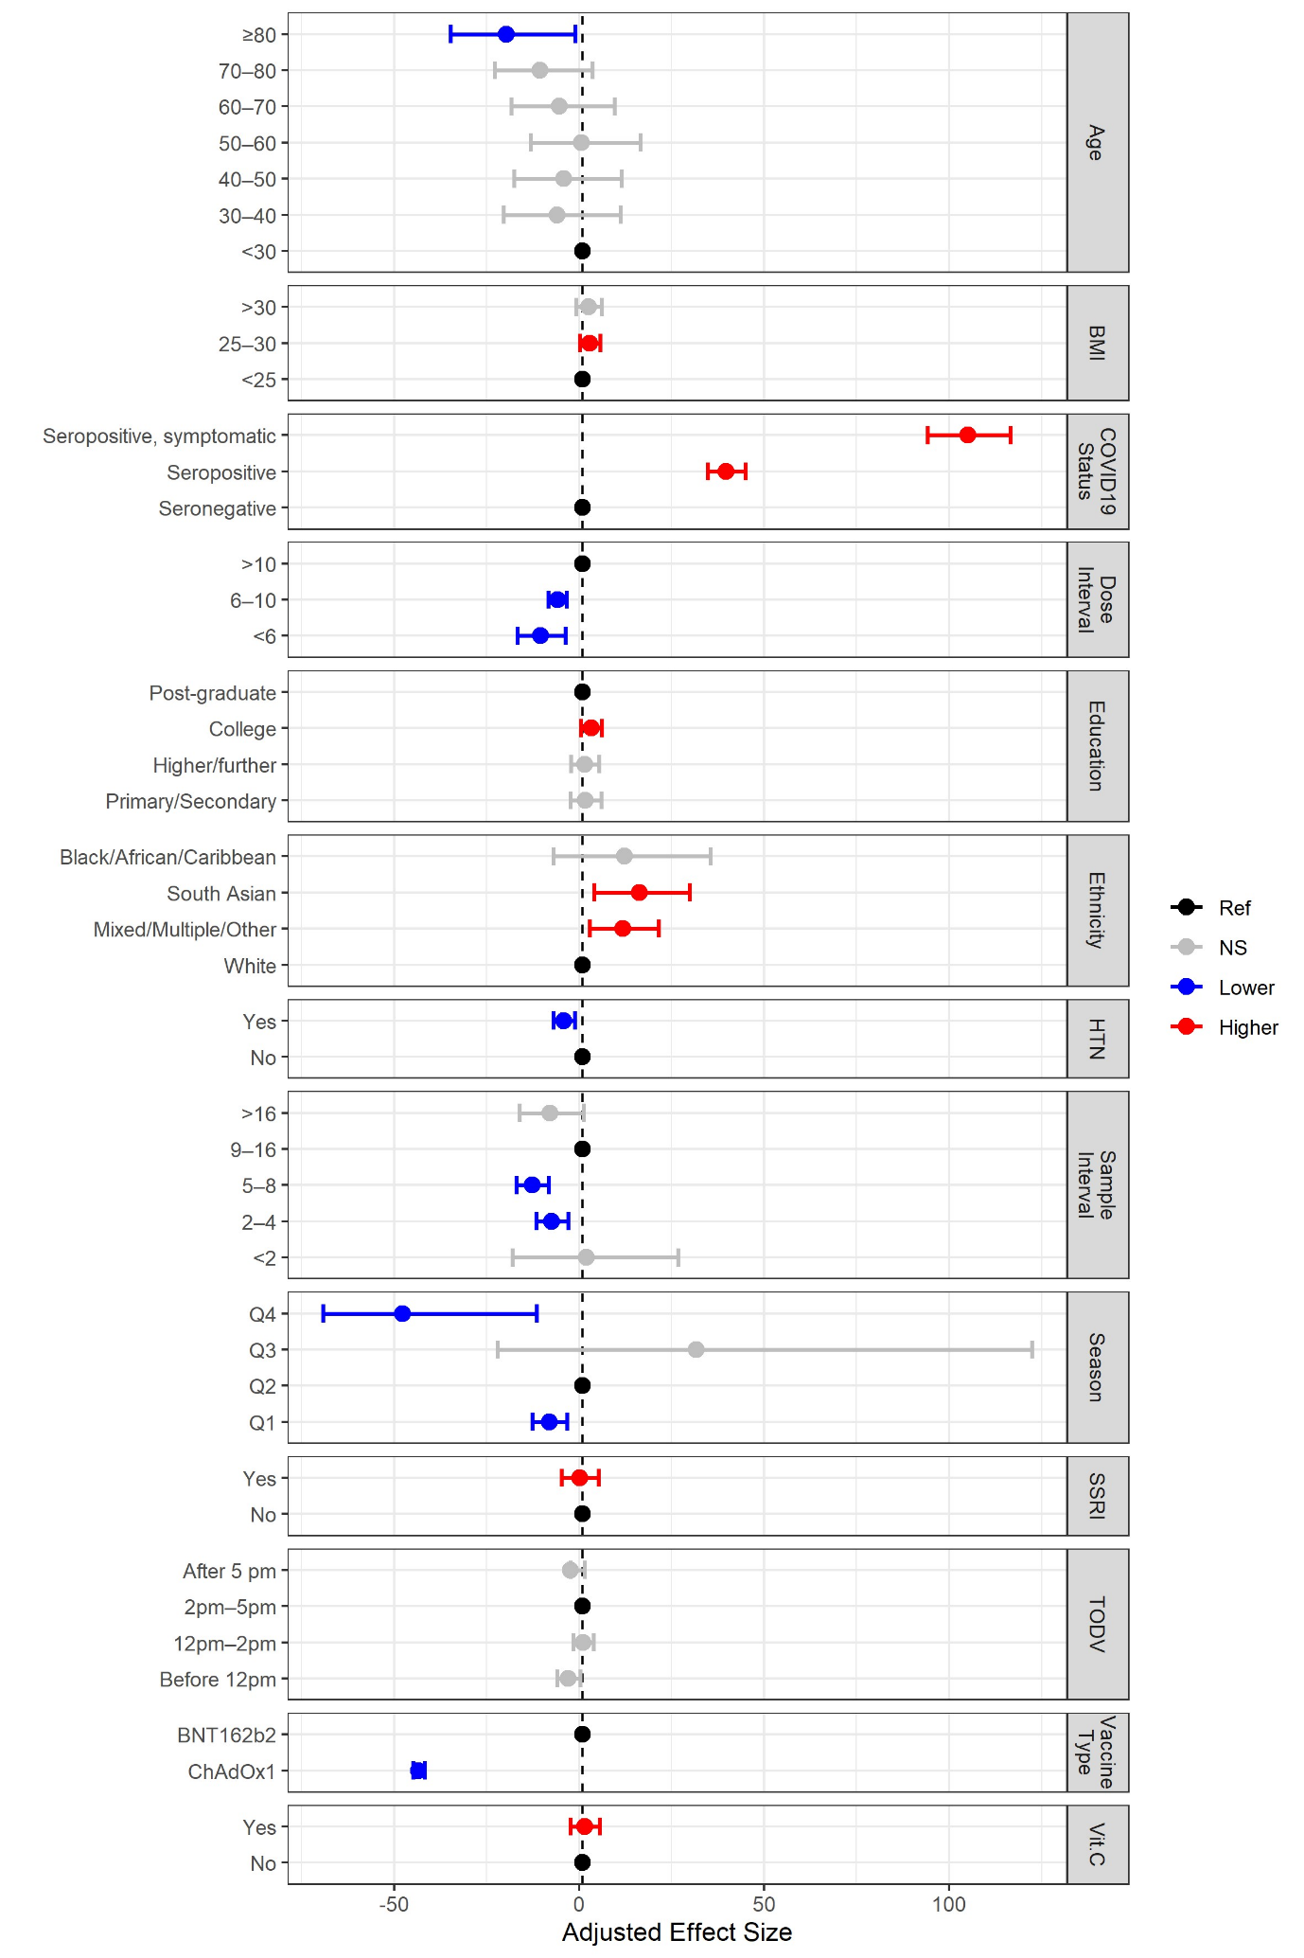

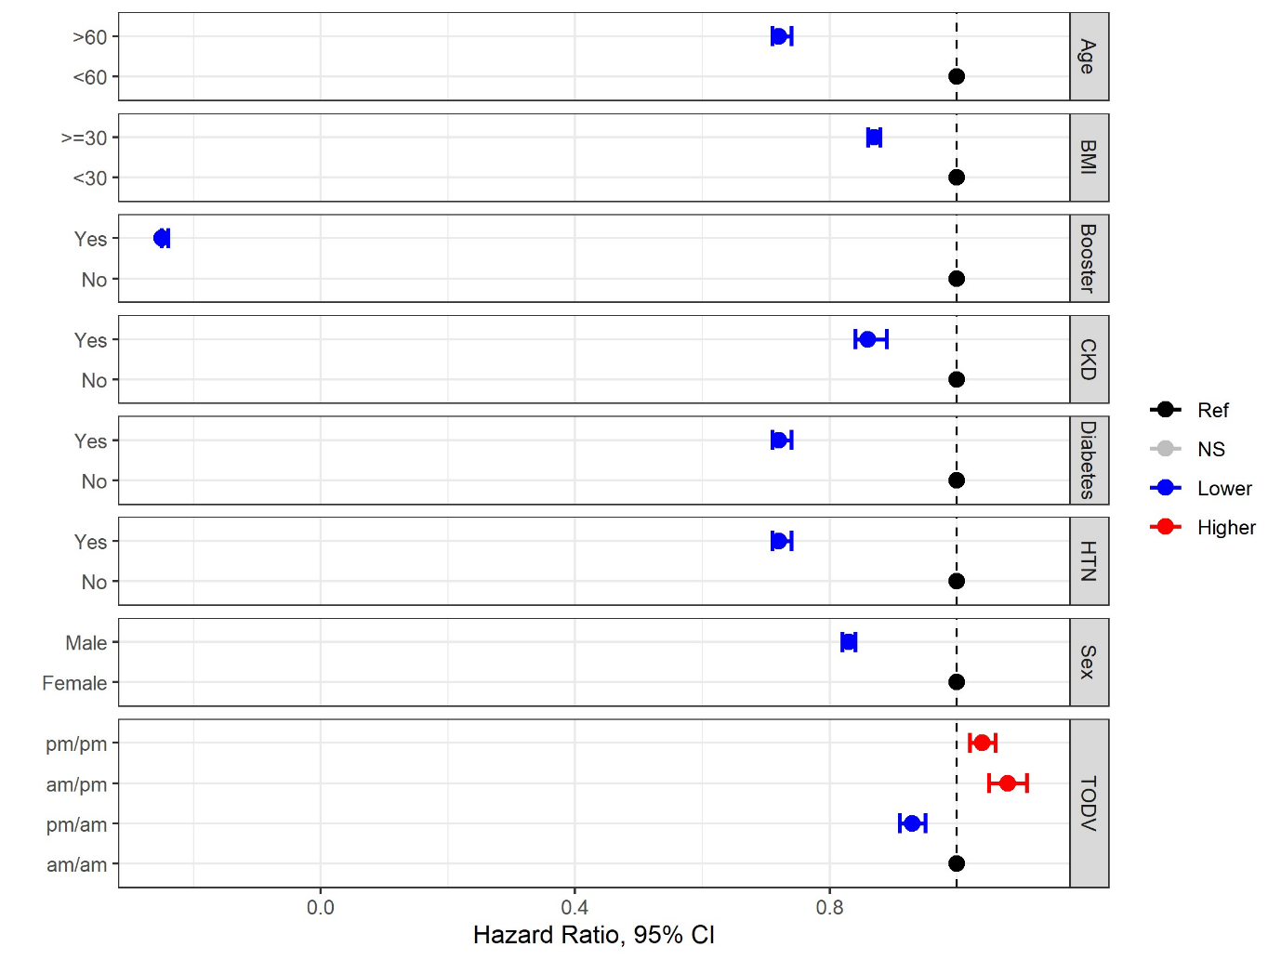
(B)

Figure 3 Summary of results of two studies that compared the effect size of TODV against other factors affecting response to vaccination. (A) Multivariable analyses reported by Jolliffe et al. 2022 showed a small (non-significant) effect of TODV on vaccination outcome (change in antibody titre) relative to other factors. (B) The effect of demographic and health related factors, including different permutations of TODV on the risk of breakthrough infection after vaccination as reported by Hazan et al., 2023.

HTN Hypertension
NS Not significant
CKD Chronic kidney disease

Table 1 Description of studies (n = 23) that investigated the effect of TODV and immune outcomes that were included in this review.
Study, year, country | Study Type and Duration | Participants, Setting | n | Age years | Female  n (%) | Vaccine,  (type) | Dose | TODV | Outcome | Confounding Factor Adjustments
Hazan  2022, Israel | Retrospective cohort  Dec 2020 - Apr 2022 | Population sample, national health service | 1.5m | > 12 | 1095633 (51.7%) | COVID19  (mRNA) | 2 | 8am-12pm  12-4pm  4-8pm | SARS-CoV-2 infection,  ED visits, hospitalisation | Sex, age, co-morbidity
Phillips (i)  2008, UK | Prospective trial  duration unknown | Students, primary care | 75 | 22.9 (3.9) mean (sd) | 41  (55%) | Hepatitis A  (Inactivated virus) | 1 | 10am-12pm  4-6pm | Hepatitis A  anti-HAV antibodies | Sex, baseline antibodies
Phillips (ii)  2008, UK | Prospective trial  duration unknown | GP surgery patients,  university | 95 | 73.1 (5.5) mean (sd) | 51  (57%) | Influenza  (Inactivated virus) | NI | 8-11am  1-4pm | Influenza HA  antibodies | Sex, baseline antibodies, negative life events
Long  2016, UK | Cluster randomised trial  2011-2013 | GP surgery patients,  primary health care | 276 | < 65 | 136  (49%) | Influenza  (Inactivated virus) | NI | 9-11am  3-5pm | Influenza HA antibodies | Baseline antibodies
Matryba  2022, Poland | Observational  Apr - Jun 2021 | Medical students,  university hospital | 1324 | 23.3 (0.05) mean (sd) | 959  (78%) | COVID19  (mRNA) | 1 & 2 | < 11am  >3pm | SARS-CoV-2 anti-S1 IgG | None
Jolliffe  2022, UK | Retrospective cohort  May 2020 - Oct 2021 | Population sample, public health services | 9101 | 62 (57.1-69.9) median (IQR) | 6414 (71% ) | COVID19  (Viral vector, mRNA) | 2 | < 12pm  12-2pm  2-5pm  > 5pm | SARS-CoV-2 anti-spike  IgG, IgA, IgM | 66 sociodemographic, behavioural, clinical, pharmacological and nutritional factors
Liu  2022, China | Randomised trial  Oct 2020 - Dec 2021 | Population sample, public health services | 418 | 50-75 | 243  (62%) | Influenza  (Inactivated virus) | NI | 9-11am  3-5pm | Influenza HA antibodies | Stratification by age, gender
Whittaker (i), 2022, UK | Longitudinal observational, duration unknown | Students, university | 75 | 22.9 (3.89) mean (sd) | 41  (54%) | Pneumococcal  (Inactivated virus) | 1 | 10am-12pm vs 4-6pm | Pneumococcal IgG | Sex
Whittaker (ii)  2022, UK | Longitudinal observational  duration unknown | Parents, research participants | 61 | 41.4 (5.31) mean (sd) | 43  (70%) | Pneumococcal  (Inactivated virus) | 1 | Morning  Afternoon | Pneumococcal IgG | Social support, Sex
Nachtigall  2022, Germany | Retrospective observational  May - Jun 2021 | Hospital employees, workplace | 8375 | 18 - 61 | 6131 (74%) | COVID-19  (Viral vector, mRNA) | 1,2,3 | Morning  Afternoon | Days off work,  adverse events | Gender, age, vaccine type and dose
Filippatos  2022, Greece | Prospective observational  Jan 2021 - Dec 2021 | Healthcare workers, university | 468 | 48.3 (13.0) mean (sd) | 361  (77%) | COVID19  (Viral vector, mRNA) | 1,2,3 | 7-11am  11-3pm  3-10pm | SARS-CoV-2 total &  neutralising anti-RBD  antibodies | Age
Wang,  2021, UK | Retrospective observational  Dec 2020 - Feb 2021 | Healthcare workers, hospital | 2784 | 16 -74 | 2302 (82%) | COVID-19  (Viral vector, mRNA) | 1 | 7-11am  11am-3pm  3-10pm | SARS-CoV-2 anti-spike,  anti-nucleocapsid IgG | Vaccine type, age, sex, days post vaccination
Langlois (i),  1995, US | Retrospective observational  Summer 1984 & 1985 | Company employees,  clinic | 98 | 45 (14.6) mean (sd) | NI | Influenza  (Inactivated virus) | NI | Continuous,  9am-4pm | Influenza HA antibodies | Age, sex, race, infection, baseline titre
Langlois (ii)  1996, US | Prospective observational  Autumn 1985 | Community,  clinic | 730 | 43.9 (0.9) mean (sd) | NI | Influenza  (Inactivated virus) | NI | Continuous,  9am-3pm | Influenza HA antibodies | Age, sex, race
Yamanaka  2022, Japan | Retrospective observational  11-27th Aug 2021 | Staff and students,  university | 332 | 20 – 64 | 184  (55%) | COVID-19  (mRNA) | 1 | Morning  Afternoon | SARS-CoV-2 neutralising  and anti-nucleocapsid IgG | Days post vaccination, sex, age, allergy, medication, sleep duration
Gottlob  2019, Germany | Randomised trial  2015-2017 | Premature infants,  hospital | 26 | 60 (1.09) days | 15  (58%) | Hexavalent primary  (Inactivated virus) | 1 | 7-10am  7 -10pm | Hexavalent vaccine  antibodies | None
Abbaspour  2022, US | Observational  Dec 2020-Apr 2021 | Employees,  workplace | 53484 | 18-95 | 36,801 (73%) | COVID-19  (mRNA) | 1 | 6-11am  11-4pm  4-10pm | Adverse events | Age, sex, ethnicity, history of allergy, epinephrine prescription
Kurupati  2017, US | Retrospective observational  2011-2015 | Community sample, university | 139 | 30-40 and  > 65 | 93  (67%) | Influenza  (Inactivated virus) | NI | 8-12pm  12-5pm | B-cell subsets, blood transcriptome, neutralising IgG | None
Karabay  2008, Turkey | Randomised trial, 6 months | Medical students,  university | 65 | 19-23 | 36  (57%) | Hepatitis B  (Recombinant) | 3 | 8-8:30am  5:30-6pm | Hepatitis B surface antigen, total core antigen antibodies | None
Erber  2023, Austria | Retrospective observational  Mar-Apr 2021 | University staff,  university | 803 | 41.9 (11.9) mean (sd) | 485  (60%) | COVID-19  (Viral vector) | 1 | Continuous  9am-4pm | SARS-CoV-2 anti-spike IgG | Baseline titre, sex and age
de Bree  2020 Netherlands | Retrospective case control  Apr 2017-Jun 2018 | Healthy volunteers, university | 52 | 26 median | 33  (61%) | BCG  (Live attenuated) | 1 | 8am-12pm  6-6.30pm | PBMC cytokine production ex vivo | None, age and sex matched
Zhang  2021, China | Prospective cohort  2021-2022 | Health care workers, hospital | 63 | 26 (24,28) median IQR | 37  (59%) | COVID-19  (Inactivated virus) | 1,2 | 9-11am  15-17pm | B-cell subsets, SARS-CoV-2 neutralising antibodies, ex vivo B and T cell responses | Age, gender
Bohn-Goldbaum 2022, Australia | Retrospective observational  Jan-Dec 2020 | Population sample, public health services | 308481 | 42.1 (27.1) mean sd | 175165 (58%) | Influenza  (Inactivated virus) | NI | Morning  Evening | Adverse events | Age, sex, concomitant vaccine, vaccine type
Feigin  1967, US | Controlled trial  11 days | Research participants, research setting | 40 | 19-26 | 0% | Venezuelan equine encephalomyelitis (Live attenuated) | 1 | 8am  8pm | Virus specific lymphocyte immunofluorescence | None
Pollman  1988, Germany | Retrospective observational  1985-1987 | Healthcare workers, hospital | 537 | NI | 318 (59.2%) | Hepatitis B  (Recombinant) | 3 | 7:30-9am  1-3pm | Anti-hepatitis B antibodies | Age, sex, season, body weight
Lai  2023, China | Randomised trial  April-May 2021 | Population sample, research setting | 503 | 33 (9)  mean (sd) | 318  (68%) | COVID-19  (Inactivated virus) | 2 | 9-11am  3-5pm | SARS-CoV-2 neutralising antibodies | Sex and age

Table 2 Risk of bias in the included studies assessed by the ROBINS-I tool
First Author | Bias due to confounding | Bias in selection of participants into the study | Bias in classification of interventions | Bias due to deviations from intended interventions | Bias due to missing data | Bias in measurement of outcomes | Bias in selection of the reported result | Overall Bias | Proposed Beneficial  TODV
Erber | Moderate | Low | Low | Low | Low | Low | Moderate | Moderate | Morning & late afternoon
Hazan | Serious | Low | Low | Low | Low | Low | Low | Serious | Morning & afternoon
Phillips | Serious | Low | Moderate | Serious | Low | Moderate | Moderate | Serious | Morning (men only)
Matryba | Serious | Moderate | Low | Moderate | Low | Moderate | Low | Serious | None
Jolliffe | Moderate | Low | Low | Low | Low | Moderate | Low | Moderate | None
Whittaker | Moderate | Moderate | Moderate | Serious | Moderate | Moderate | Serious | Serious | None
Nachtigall | Moderate | Moderate | Moderate | Low | Low | Low | Low | Moderate | None
Filippatos | Serious | Low | Moderate | Moderate | Moderate | Moderate | Moderate | Serious | None
Wang | Moderate | Moderate | Moderate | Moderate | Moderate | Moderate | Moderate | Moderate | Afternoon
Langlois | Serious | Moderate | Serious | Moderate | Moderate | Moderate | Low | Serious | Midday (1pm)
Yamanaka | Moderate | Low | Moderate | Low | Moderate | Moderate | Low | Moderate | None
Abbaspour | Serious | Low | Moderate | Moderate | Low | Low | Moderate | Serious | Afternoon/Evening
Kurupati | Serious | Serious | Serious | Moderate | Moderate | Low | Serious | Serious | Afternoon (aged only)
de Bree | Serious | Serious | Moderate | Low | Low | Moderate | Moderate | Serious | Morning
Zhang | Serious | Moderate | Low | Low | Moderate | Low | Low | Moderate | Morning
Bohn-Goldbaum | Serious | Low | Moderate | Low | Moderate | Low | Low | Serious | None
Feigin | Serious | Low | Low | Low | Low | Low | Moderate | Serious | Afternoon
Pollman | Critical | Serious | Moderate | Moderate | Moderate | Low | Low | Critical | Afternoon

Table 3 Risk of bias in the included studies assessed by the ROB2 tool.
!
!
!
?
Study ID | D1 | D2 | D3 | D4 | D5 | Overall | Proposed Beneficial TODV
Karabay | ! | ! | + | ! | ! |  | None | Low risk
Long | ! | + | + | ! | ! |  | Morning | Some concerns | +
Liu | ? | ? | + | + | ? | ? | Morning (only in older women) | High risk
Gottlob | ? | ? | + | ! | + |  | None |  | ?
Lai |  |  |  | ?  +  +  +  + |  |  | None |  | !
D1 Randomisation process
D2 Deviations from the intended interventions
D3 Missing outcome data
D4 Measurement of the outcome
D5 Selection of the reported result

